CSO Run 1 Bolometers: Time Constants

Matt Gardner (Caltech)

Version: 18 April 2001

Acknowledgements

Christine Allen (NASA/GSFC) provided the bolometers. Jeff Groseth (Caltech) mounted and wirebonded all devices. Matt Gardner and C. Darren Dowell (Caltech) performed all measurements.
Thanks also to C. Darren Dowell for feedback and guidance.

Apparatus

Cryostat 1) Caltech Barney Dewar (2000 Dec. 1 to 2001 Mar. 1) – IR Labs HDL-10 with helium shield + Chase Research single-stage ³He fridge; 2) SHARCII Dewar (all other dates) – Made to design by Precision Cryogenics, with helium shield + Chase Research ³He/⁴He fridge. Both cryostats have RFI filtered connectors with 1-4 nF capacitance.

Detector holder Devices are attached to an alumina or fiberglass PC board with gold-plated copper traces. The PC board is screwed to an Invar base, and a black painted Invar lid covers the detectors. Gold wirebonds (0.001”) provide electrical interface to each device. A calibrated Lakeshore G.R.T. is attached to the PC board with a screw and N grease. The Invar base is: 1) Attached with screws and N grease to a copper cradle, which is attached to the fridge coldhead with screws and N grease (Barney); 2) Suspended from 4 K surface by 3 fiberglass tubes and connected to coldhead by a long copper cold bar (SHARCII).

Bolometer Mounting Method varies with type of device package. 3-element dies are attached with GE varnish at the die corners, up to 6 at once (Barney only). 16- and 32-element arrays are attached with Cu or BeCu clips at one or both ends, respectively, with the clips attached to the PC board with screws (both cryostats).

Methods Load resistors and JFETs inside dewar are used during measurements. Bolometer is biased either with a square wave between (V_{bias} - ΔV/2) and (V_{bias} + ΔV/2) [“Stepped Bias”] or with V(t) = V_{bias} + ΔVsin(ωt) [“Frequency Response”], where ΔV << V_{bias}. Output response is: 1) Amplified by a Stanford Research 560 preamp and displayed on an HP 54645D oscilloscope for measurement (prior to 2001 Mar. 1); 2) Sampled at 1 kHz with an A/D system with 20 μV resolution (after 2001 Mar. 1).

Measurement Period CSO1 devices were measured between 2000 Dec. 1 and 2001 Mar. 30, along with some G₀ and thermistor test arrays. Additional test array measurements from April-July 2000, using the SHARC II dewar, are also included (for more detail, see “Pop-Up Detector Report”, version 2.0, by C. Darren Dowell).

Theory

Figure 1: Bolometer test circuit.
Shown in red are assumed capacitive properties of the wiring.

Figure 1 shows the circuit used for device testing. The measurable output is V + V_{offset}, where V is the voltage across the bolometer and V_{offset} is a property of the JFET. In analysis, V_{offset} is measured and removed, so that V is known; since the bias voltage and load resistance, R_{L}, are also known, the current through the bolometer, I, can be calculated. Taking this I-V data at several base temperatures, we are then able to fit the bolometer to the following model:

- R(T) = R₀ * exp((Δ/T)^{1/2}), where T is the bolometer’s operating temperature and R = V/I its resistance
- G(T) = G₀ * T^{β}, where G is the bolometer’s thermal conductance

The best-fit model for each device tested may then be used to derive many other aspects of its response and behavior.
$τ=τe⋅\frac{2R(Z+RL)}{(Z+R)(R+RL)}$For example, the bolometer’s physical time constant is τ = C/G, where C is the device’s heat capacity. However, due to electrothermal feedback, the bolometer’s response to both incident radiation and changes in bias voltage has a different effective time constant, τ_{e}. The two time constants are related by
where Z = dV/dI is the DC bolometer impedance (Mather, 1982). Given a base temperature to which the devices are cooled, T_{base}, and a DC bias voltage, V_{bias}, the derived models can estimate T, R, Z, and G; thus, measurement of either time constant allows the calculation of the other, as well as of C.

Stepped Bias Measurements

For a given base detector temperature and background load, device models can predict the bias voltage, V_{opt}, which minimizes bolometer NEP at a given frequency; for these measurements that frequency was 0.01 Hz, and an amplifier noise of 5 nV/Hz^{1/2} was assumed. Bolometer responses have typically been measured for V_{bias}/V_{opt} ~ 0.5, 1, and 2 at several base temperatures. The frequency of the applied square wave bias is selected so that a full thermal settling of the bolometer is visibly apparent before the next waveform edge.
Sample bolometer responses from December 1 are shown in Figures 2 and 3 below; indicated in red on Figure 2 are the voltages measured for every observed response, while measured times are shown in blue. Figure 4 shows a plot of an output as measured with the A/D system, as well as a best-fit profile.

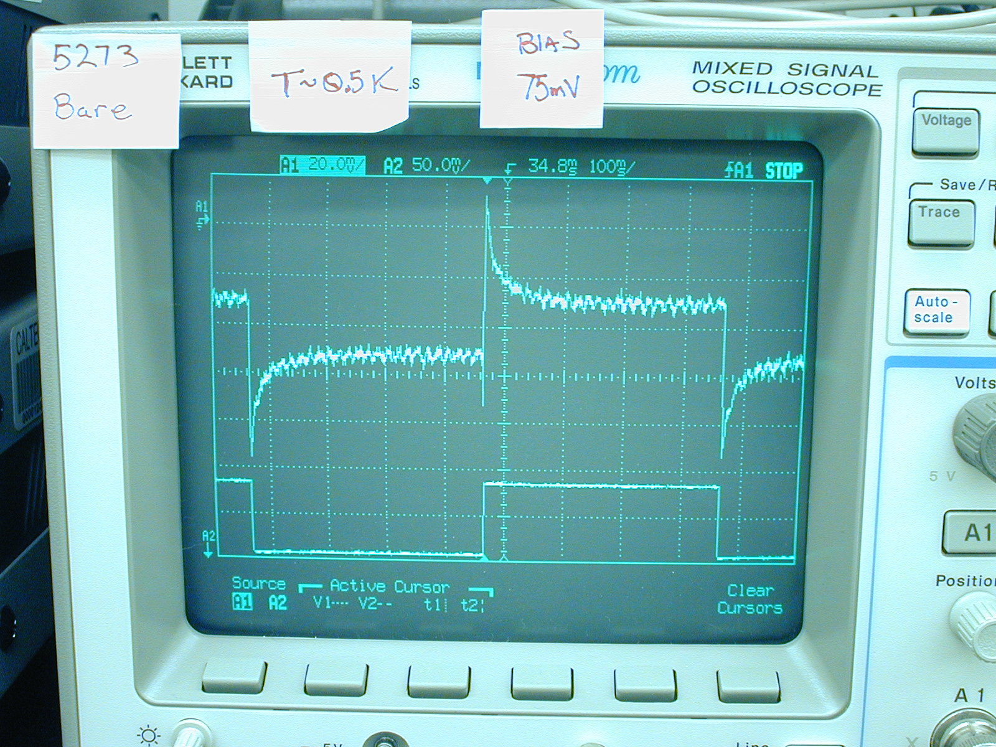
V_{rise}

V_{OS}
V_{OS} / e
τ_{OS}
τ_{settle}
Figure 2: Bias voltage (bottom) and response (top) of bare 5273.7200 T2 device at T_{base} = 502 mK, V_{bias} ~ V_{opt}, R_{L} = 21.48 MΩ; both signals are amplified by a factor of 100. Measured τ_{settle} is 13.2 msec.

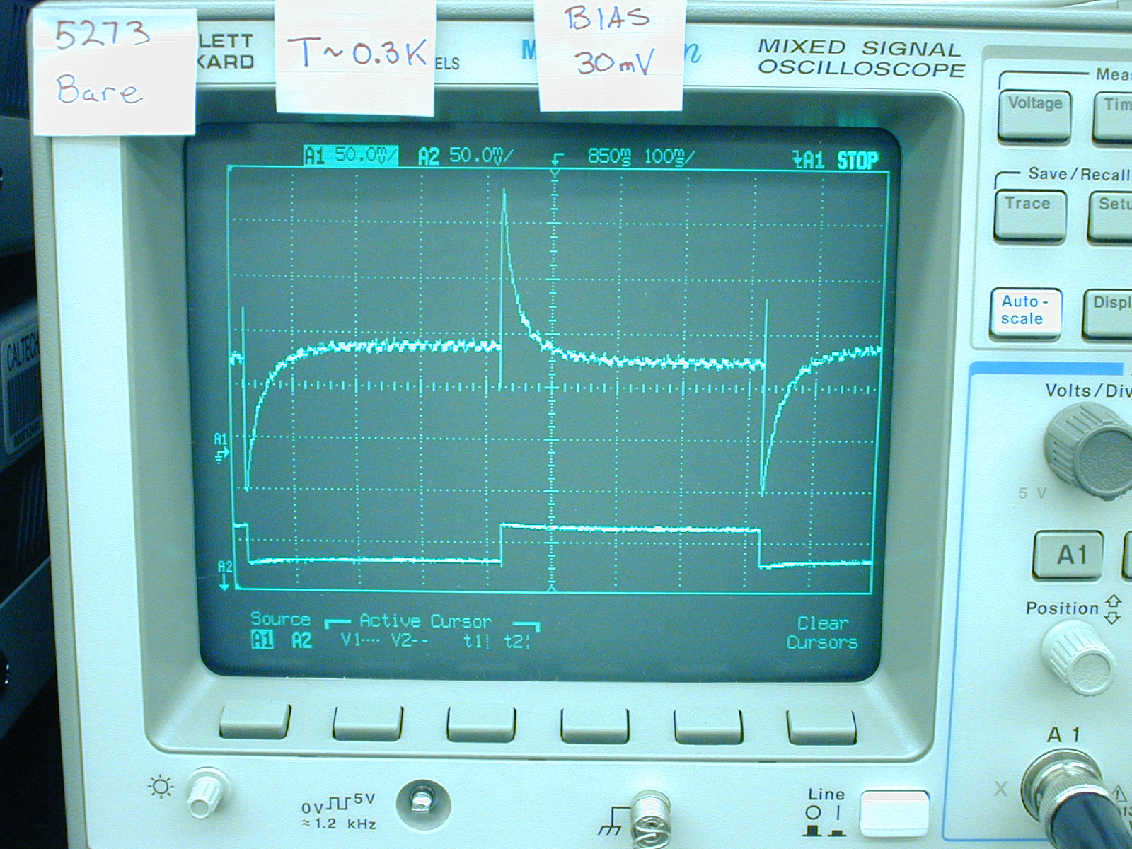
Figure 3: Same as Figure 2, except T_{base} = 282 mK. Measured τ_{settle} is 22.8 msec.

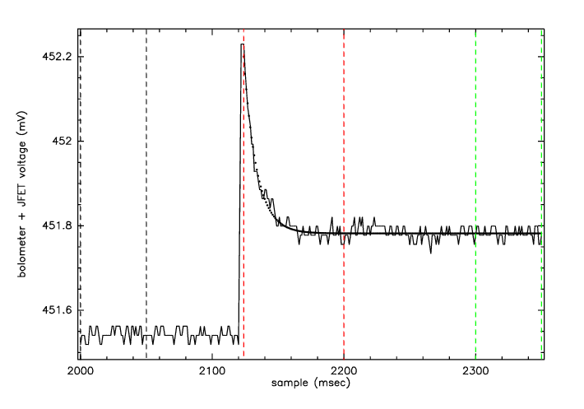
Figure 4: The thin black line is the output using the A/D system, and the thick black line is the best-fit exponential profile. The vertical dashed lines mark user-selected windows on which the same quantities as in Figure 2 are measured, yielding this fit.

Table 1: Stepped Bias Measurements – CSO1 3-element dies
Die | Device Type | Bol. Loc. | Date | T_{base} (mK) | V_{bias} (mV) | ΔV (mV) | τ_{settle} (ms) | T (mK) | G (nW/K) | τ_{e}/τ | C (pJ/K)
5045.7000 T4 | bare bolometer | right | 12/19/00 | 284 | 33.9 | 0.94 | 17.2 | 325 | 0.238 | 1.333 | 3.07
5045.7000 T4 | bare bolometer | right | 12/19/00 | 500 | 41.8 | 10.0 | 8.0 | 517 | 0.538 | 0.915 | 4.70
5045.7000 T4 | bare bolometer | right | 12/19/00 | 500 | 84.6 | 5.00 | 7.7 | 554 | 0.606 | 0.783 | 5.96
5045.7000 T4 | bare bolometer | right | 12/19/00 | 500 | 170.0 | 5.00 | 5.6 | 627 | 0.754 | 0.639 | 6.61
5045.7000 T4 | bolometer w/ SiO/Bi/SiO | left | 12/19/00 | 284 | 33.9 | 0.94 | 27.6 | 336 | 0.204 | 1.255 | 4.49
5045.7000 T4 | bolometer w/ SiO/Bi/SiO | left | 12/19/00 | 499 | 41.8 | 7.50 | 16.8 | 519 | 0.454 | 0.904 | 8.44
5045.7000 T4 | bolometer w/ SiO/Bi/SiO | left | 12/19/00 | 499 | 84.6 | 5.00 | 10.0 | 558 | 0.519 | 0.769 | 6.75
5045.7000 T4 | bolometer w/ SiO/Bi/SiO | left | 12/19/00 | 499 | 170.0 | 5.00 | 5.9 | 634 | 0.658 | 0.631 | 6.15
5273.7200 T1 | bare bolometer | right | 12/19/00 | 284 | 14.6 | 4.69 | 10.8 | 294 | 0.183 | 0.961 | 2.06
5273.7200 T1 | bare bolometer | right | 12/19/00 | 284 | 28.3 | 2.03 | 8.4 | 316 | 0.208 | 0.853 | 2.05
5273.7200 T1 | bare bolometer | right | 12/19/00 | 284 | 57.4 | 2.03 | 6.5 | 362 | 0.268 | 0.673 | 2.59
5273.7200 T1 | bare bolometer | right | 12/19/00 | 501 | 135.0 | 19.4 | 6.7 | 550 | 0.568 | 0.790 | 4.82
5273.7200 T1 | bolometer w/ SiO/Bi/SiO | left | 12/19/00 | 284 | 14.6 | 4.69 | 19.2 | 296 | 0.138 | 0.945 | 2.80
5273.7200 T1 | bolometer w/ SiO/Bi/SiO | left | 12/19/00 | 284 | 28.3 | 2.03 | 20.4 | 321 | 0.160 | 0.819 | 3.99
5273.7200 T1 | bolometer w/ SiO/Bi/SiO | left | 12/19/00 | 284 | 57.4 | 2.03 | 12.6 | 372 | 0.211 | 0.647 | 4.11
5273.7200 T1 | bolometer w/ SiO/Bi/SiO | left | 12/19/00 | 501 | 135.0 | 10.0 | 13.4 | 557 | 0.450 | 0.775 | 7.78

Table 1 (cont.)
5273.7200 T2 | bare bolometer | mid | 12/1/00 | 282 | 15.7 | 3.92 | 33.2 | 310 | 0.118 | 1.066 | 3.68
5273.7200 T2 | bare bolometer | mid | 12/1/00 | 282 | 29.4 | 3.92 | 22.8 | 359 | 0.158 | 0.848 | 4.25
5273.7200 T2 | bare bolometer | mid | 12/1/00 | 282 | 58.8 | 7.84 | 12.8 | 441 | 0.240 | 0.610 | 5.04
5273.7200 T2 | bare bolometer | mid | 12/1/00 | 397 | 21.6 | 3.92 | 29.2 | 417 | 0.215 | 0.903 | 6.95
5273.7200 T2 | bare bolometer | mid | 12/1/00 | 398 | 45.1 | 3.92 | 14.9 | 459 | 0.260 | 0.758 | 5.11
5273.7200 T2 | bare bolometer | mid | 12/1/00 | 398 | 88.2 | 7.84 | 10.1 | 528 | 0.345 | 0.627 | 5.56
5273.7200 T2 | bare bolometer | mid | 12/1/00 | 501 | 37.3 | 3.92 | 37.2 | 521 | 0.336 | 0.896 | 13.95
5273.7200 T2 | bare bolometer | mid | 12/1/00 | 502 | 74.5 | 7.84 | 13.2 | 561 | 0.389 | 0.769 | 6.68
5273.7200 T2 | bare bolometer | mid | 12/1/00 | 502 | 147.1 | 15.69 | 12.2 | 635 | 0.500 | 0.649 | 9.40
5273.7200 T4 | bare bolometer | mid | 12/7/00 | 283 | 16.5 | 1.03 | N/A | 301 | 0.144 | 1.212 | N/A
5273.7200 T4 | bare bolometer | mid | 12/7/00 | 283 | 30.2 | 1.03 | 27.0 | 349 | 0.187 | 1.214 | 4.16
5273.7200 T4 | bare bolometer | mid | 12/7/00 | 283 | 61.3 | 1.03 | 8.0 | 456 | 0.300 | 0.657 | 3.65
5273.7200 T4 | bare bolometer | mid | 12/7/00 | 283 | 119.5 | 4.06 | 6.1 | 567 | 0.441 | 0.515 | 5.22
5273.7200 T4 | bare bolometer | mid | 12/7/00 | 384 | 20.4 | 1.94 | 17.2 | 405 | 0.243 | 0.961 | 4.35
5273.7200 T4 | bare bolometer | mid | 12/7/00 | 384 | 39.7 | 1.94 | 14.8 | 446 | 0.289 | 0.820 | 5.22
5273.7200 T4 | bare bolometer | mid | 12/7/00 | 384 | 80.6 | 1.94 | 7.6 | 528 | 0.390 | 0.625 | 4.74
5273.7200 T4 | bare bolometer | mid | 12/7/00 | 384 | 160.0 | 2.88 | 4.6 | 638 | 0.545 | 0.531 | 4.72
5273.7200 T4 | bare bolometer | mid | 12/7/00 | 505 | 33.9 | 3.91 | 10.0 | 526 | 0.387 | 0.901 | 4.30
5273.7200 T4 | bare bolometer | mid | 12/7/00 | 506 | 68.8 | 3.91 | 11.3 | 569 | 0.445 | 0.764 | 6.58
5273.7200 T4 | bare bolometer | mid | 12/7/00 | 506 | 136.8 | 3.91 | 8.5 | 650 | 0.562 | 0.630 | 7.58
5273.7200 T4 | bare bolometer | mid | 12/7/00 | 506 | 272.6 | 5.78 | 4.6 | 773 | 0.765 | 0.552 | 6.38
5311.7000 T2 | bare bolometer | right | 12/16/00 | 284 | 26.3 | 5 | 10.0 | 311 | 0.247 | 0.967 | 3.22
5311.7000 T2 | bare bolometer | right | 12/16/00 | 284 | 49.5 | 5 | 7.0 | 354 | 0.310 | 0.767 | 2.83
5311.7000 T2 | bare bolometer | right | 12/16/00 | 284 | 97.9 | 10 | 3.6 | 426 | 0.427 | 0.582 | 2.64
5311.7000 T2 | bare bolometer | right | 12/17/00 | 498 | 117.5 | 20 | 4.3 | 546 | 0.659 | 0.788 | 3.60
5311.7000 T2 | bolometer w/ Bi | left | 12/16/00 | 284 | 26.3 | 5 | 14.0 | 318 | 0.183 | 0.910 | 2.82
5311.7000 T2 | bolometer w/ Bi | left | 12/16/00 | 284 | 49.5 | 5 | 9.4 | 366 | 0.236 | 0.710 | 3.12
5311.7000 T2 | bolometer w/ Bi | left | 12/16/00 | 284 | 97.9 | 10 | 6.8 | 440 | 0.331 | 0.563 | 4.00
5311.7000 T2 | bolometer w/ Bi | left | 12/17/00 | 497 | 117.5 | 20 | 8.0 | 553 | 0.502 | 0.767 | 5.24
5311.7000 T4 | bare bolometer | right | 12/16/00 | 284 | 20.4 | 4 | 29.0 | 312 | 0.115 | 1.258 | 2.65
5311.7000 T4 | bare bolometer | right | 12/16/00 | 284 | 39.7 | 4 | 16.0 | 389 | 0.165 | 0.878 | 3.01
5311.7000 T4 | bare bolometer | right | 12/16/00 | 284 | 78.6 | 4 | 6.6 | 491 | 0.242 | 0.558 | 2.86
5311.7000 T4 | bare bolometer | right | 12/17/00 | 497 | 35.8 | 10 | 12.4 | 521 | 0.268 | 0.882 | 3.77
5311.7000 T4 | bare bolometer | right | 12/17/00 | 497 | 68.8 | 10 | 9.6 | 561 | 0.303 | 0.749 | 3.88
5311.7000 T4 | bare bolometer | right | 12/17/00 | 498 | 136.8 | 10 | 6.7 | 641 | 0.377 | 0.615 | 4.11
5311.7000 T4 | bolometer w/ SiO/Bi/SiO | left | 12/16/00 | 284 | 20.4 | 4 | 35.0 | 315 | 0.112 | 1.225 | 3.20
5311.7000 T4 | bolometer w/ SiO/Bi/SiO | left | 12/16/00 | 284 | 39.7 | 4 | 19.2 | 388 | 0.159 | 0.850 | 3.59
5311.7000 T4 | bolometer w/ SiO/Bi/SiO | left | 12/16/00 | 284 | 78.6 | 4 | 9.2 | 488 | 0.234 | 0.561 | 3.84
5311.7000 T4 | bolometer w/ SiO/Bi/SiO | left | 12/17/00 | 496 | 35.8 | 10 | 17.6 | 519 | 0.259 | 0.887 | 5.14
5311.7000 T4 | bolometer w/ SiO/Bi/SiO | left | 12/17/00 | 496 | 68.8 | 10 | 14.4 | 559 | 0.294 | 0.754 | 5.61
5311.7000 T4 | bolometer w/ SiO/Bi/SiO | left | 12/17/00 | 499 | 136.8 | 10 | 9.0 | 638 | 0.367 | 0.624 | 5.29
NOTE: Cases where V_{bias} ~ V_{opt} are shown in bold.

Table 2: Stepped Bias Measurements – G₀ and Thermistor Test Arrays, Type 2B
Array & Design Type | Device Type | Bol. # | Date | T_{base} (mK) | V_{bias} (mV) | ΔV (mV) | τ_{settle} (ms) | T (mK) | G (nW/K) | τ_{e}/τ | C (pJ/K)
5347^{G0} LH1 2B1 | bare bolometer | 2 | 2/3/01 | 273 | 54.9 | 3.92 | 4.9 | 338 | 0.270 | 0.693 | 1.91
5347^{G0} LH1 2B1 | bare bolometer | 2 | 1/11/01 | 282 | 74.5 | 7.84 | 3.8 | 381 | 0.279 | 0.613 | 1.73
5347^{G0} LH1 2B1 | bare bolometer | 2 | 2/3/01 | 273 | 109.8 | 3.92 | 2.8 | 405 | 0.348 | 0.566 | 1.72
5347^{G0} LH1 2B1 | bare bolometer | 2 | 2/3/01 | 273 | 219.6 | 7.84 | 2.3 | 501 | 0.470 | 0.508 | 2.13
5347^{G0} LH1 2B1 | bare bolometer | 2 | 2/3/01 | 492 | 151.0 | 11.8 | 3.7 | 547 | 0.532 | 0.782 | 2.52
5347^{G0} LH1 2B1 | bare bolometer | 2 | 2/3/01 | 492 | 302.0 | 23.5 | 2.7 | 626 | 0.643 | 0.657 | 2.64
5347^{G0} LH1 2B1 | bare bolometer | 3 | 1/11/01 | 282 | 19.6 | 3.92 | 6.6 | 297 | 0.198 | 0.919 | 1.42
5347^{G0} LH1 2B1 | bare bolometer | 3 | 1/11/01 | 282 | 37.3 | 3.92 | 5.2 | 323 | 0.229 | 0.782 | 1.52
5347^{G0} LH1 2B1 | bare bolometer | 3 | 1/11/01 | 283 | 37.3 | 3.92 | 5.6 | 324 | 0.230 | 0.783 | 1.64
5347^{G0} LH1 2B1 | bare bolometer | 3 | 1/11/01 | 282 | 74.5 | 7.84 | 3.4 | 375 | 0.298 | 0.619 | 1.64
5347^{G0} LH1 2B1 | bare bolometer | 3 | 1/11/01 | 282 | 74.5 | 7.84 | 3.4 | 375 | 0.298 | 0.619 | 1.64
5347^{G0} LH1 2B1 | bare bolometer | 3 | 1/11/01 | 505 | 74.5 | 31.4 | 4.0 | 520 | 0.530 | 0.916 | 2.31
5347^{G0} LH1 2B1 | bare bolometer | 3 | 1/11/01 | 504 | 151.0 | 15.7 | 4.0 | 551 | 0.587 | 0.794 | 2.96
5347^{G0} LH1 2B1 | bare bolometer | 3 | 1/11/01 | 505 | 300.0 | 31.4 | 2.8 | 618 | 0.720 | 0.670 | 3.01
5347^{G0} LH1 2B1 | bare bolometer | 4 | 2/3/01 | 273 | 54.9 | 3.92 | 3.1 | 338 | 0.270 | 0.697 | 1.20
5347^{G0} LH1 2B1 | bare bolometer | 4 | 1/11/01 | 282 | 74.5 | 7.84 | 3.1 | 374 | 0.301 | 0.621 | 1.50
5347^{G0} LH1 2B1 | bare bolometer | 4 | 2/3/01 | 273 | 109.8 | 3.92 | 2.5 | 405 | 0.348 | 0.564 | 1.54
5347^{G0} LH1 2B1 | bare bolometer | 4 | 2/3/01 | 273 | 219.6 | 7.84 | 2.0 | 501 | 0.467 | 0.505 | 1.85
5347^{G0} LH1 2B1 | bare bolometer | 4 | 2/3/01 | 492 | 151.0 | 11.8 | 3.6 | 547 | 0.529 | 0.780 | 2.44
5347^{G0} LH1 2B1 | bare bolometer | 4 | 2/3/01 | 493 | 302.0 | 23.5 | 2.4 | 627 | 0.639 | 0.655 | 2.34
5347^{G0} LH1 2B | bare bolometer | 24 | 4/18/00 | 327 | 19.6 | 7.84 | 4.5 | 340 | 0.263 | 0.976 | 1.22
5347^{G0} LH1 2B | bare bolometer | 24 | 4/18/00 | 327 | 39.2 | 7.84 | 3.6 | 370 | 0.302 | 0.861 | 1.26
5347^{G0} LH1 2B | bare bolometer | 24 | 4/18/00 | 327 | 78.4 | 7.84 | 2.3 | 432 | 0.389 | 0.662 | 1.35
5347^{G0} LH1 2B | bare bolometer | 24 | 4/18/00 | 327 | 156.9 | 7.84 | 1.3 | 524 | 0.535 | 0.543 | 1.28
5347Th RH7 2B4 | bare bolometer | 10 | 4/28/00 | 330 | 49.0 | 7.84 | 3.6 | 401 | 0.333 | 0.882 | 1.36
5347Th RH7 2B4 | bare bolometer | 10 | 4/28/00 | 330 | 98.0 | 7.84 | 2.1 | 488 | 0.486 | 0.629 | 1.62
5347Th RH7 2B1 | bare bolometer | 23 | 4/28/00 | 330 | 49.0 | 7.84 | 4.2 | 385 | 0.347 | 0.801 | 1.82
5347Th RH7 2B1 | bare bolometer | 23 | 4/28/00 | 330 | 98.0 | 7.84 | 2.8 | 454 | 0.452 | 0.608 | 2.08
5347Th RH7 2B2 | bolometer w/ PdAu | 21 | 6/22/00 | 345 | 23.5 | 7.84 | 20.8 | 363 | 0.272 | 1.039 | 5.45
5347Th RH7 2B2 | bolometer w/ PdAu | 21 | 6/22/00 | 345 | 49.0 | 7.84 | 14.8 | 412 | 0.348 | 0.897 | 5.74
5347Th RH7 2B2 | bolometer w/ PdAu | 21 | 6/22/00 | 345 | 74.5 | 7.84 | 14.6 | 460 | 0.433 | 0.727 | 8.70
5347Th RH7 2B2 | bolometer w/ PdAu | 21 | 6/22/00 | 345 | 98.0 | 7.84 | 12.2 | 497 | 0.505 | 0.642 | 9.60
5347Th RH7 2B1 | bolometer w/ PdAu | 23 | 6/22/00 | 345 | 23.5 | 7.84 | 16.3 | 361 | 0.288 | 0.949 | 4.95
5347Th RH7 2B1 | bolometer w/ PdAu | 23 | 6/22/00 | 345 | 49.0 | 7.84 | 19.0 | 398 | 0.341 | 0.796 | 8.14
5347Th RH7 2B1 | bolometer w/ PdAu | 23 | 6/22/00 | 345 | 74.5 | 7.84 | 16.1 | 435 | 0.398 | 0.681 | 9.41
5347Th RH7 2B1 | bolometer w/ PdAu | 23 | 6/22/00 | 345 | 98.0 | 7.84 | 15.5 | 465 | 0.448 | 0.618 | 11.24
5347Th RH7 2B | bolometer w/ PdAu | 30 | 6/22/00 | 345 | 74.5 | 7.84 | 14.6 | 448 | 0.434 | 0.715 | 8.86
5347Th LH3 2B2 | bare bolometer | 4 | 12/21/00 | 284 | 35.8 | 3.91 | 8.2 | 340 | 0.231 | 1.076 | 1.76
5347Th LH3 2B2 | bare bolometer | 4 | 12/21/00 | 500 | 92.4 | 8.75 | 6.0 | 560 | 0.559 | 0.773 | 4.34

Table 2 (cont.)
5347Th LH3 2B1 | bare bolometer | 5 | 12/21/00 | 284 | 59.3 | 7.03 | 4.4 | 376 | 0.287 | 0.676 | 1.87
5347Th LH3 2B1 | bare bolometer | 5 | 7/3/00 | 329 | 39.2 | 7.84 | 7.8 | 365 | 0.305 | 0.827 | 2.88
5347Th LH3 2B1 | bare bolometer | 5 | 7/3/00 | 329 | 58.8 | 7.84 | 5.1 | 392 | 0.345 | 0.717 | 2.45
5347Th LH3 2B1 | bare bolometer | 5 | 12/21/00 | 326 | 59.4 | 10.0 | 4.2 | 396 | 0.312 | 0.709 | 1.85
5347Th LH3 2B1 | bare bolometer | 5 | 7/3/00 | 329 | 82.4 | 7.84 | 5.3 | 423 | 0.392 | 0.633 | 3.28
5347Th LH3 2B1 | bare bolometer | 5 | 12/21/00 | 326 | 82.6 | 10.0 | 3.2 | 427 | 0.354 | 0.632 | 1.79
5347Th LH3 2B1 | bare bolometer | 5 | 12/21/00 | 326 | 97.9 | 10.0 | 2.6 | 445 | 0.380 | 0.601 | 1.64
5347Th LH3 2B1 | bare bolometer | 5 | 7/3/00 | 329 | 98.0 | 7.84 | 3.7 | 439 | 0.420 | 0.600 | 2.59
5347Th LH3 2B1 | bare bolometer | 5 | 12/21/00 | 501 | 125.0 | 9.69 | 4.8 | 557 | 0.551 | 0.765 | 3.46
5347Th LH3 2B | bare bolometer | 6 | 12/21/00 | 284 | 31.9 | 3.91 | 11.7 | 329 | 0.225 | 1.027 | 2.56
5347Th LH3 2B | bare bolometer | 6 | 7/3/00 | 329 | 39.2 | 7.84 | 7.2 | 374 | 0.309 | 0.887 | 2.51
5347Th LH3 2B | bare bolometer | 6 | 12/21/00 | 327 | 64.9 | 10.0 | 4.9 | 421 | 0.345 | 0.714 | 2.37
5347Th LH3 2B | bare bolometer | 6 | 7/3/00 | 329 | 64.7 | 7.84 | 6.1 | 418 | 0.377 | 0.720 | 3.19
5347Th LH3 2B | bare bolometer | 6 | 7/3/00 | 329 | 78.4 | 7.84 | 4.4 | 439 | 0.410 | 0.663 | 2.72
5347Th LH3 2B | bare bolometer | 6 | 12/21/00 | 327 | 98.0 | 10.0 | 3.4 | 472 | 0.420 | 0.611 | 2.34
5347Th LH3 2B | bare bolometer | 6 | 7/3/00 | 329 | 98.0 | 7.84 | 4.1 | 466 | 0.457 | 0.609 | 3.08
5347Th LH3 2B | bare bolometer | 6 | 12/21/00 | 500 | 101.9 | 9.69 | 4.5 | 559 | 0.561 | 0.771 | 3.27
5347Th LH3 2B2 | bolometer w/ PdAu | 18 | 12/21/00 | 284 | 43.7 | 3.91 | 31.0 | 364 | 0.249 | 1.046 | 7.38
5347Th LH3 2B2 | bolometer w/ PdAu | 18 | 12/21/00 | 326 | 59.4 | 10.0 | 20.4 | 426 | 0.333 | 0.780 | 8.71
5347Th LH3 2B2 | bolometer w/ PdAu | 18 | 12/21/00 | 326 | 97.9 | 10.0 | 14.8 | 496 | 0.440 | 0.617 | 10.55
5347Th LH3 2B2 | bolometer w/ PdAu | 18 | 12/21/00 | 498 | 82.6 | 7.81 | 12.5 | 555 | 0.542 | 0.786 | 8.62
5347Th LH3 2B1 | bolometer w/ PdAu | 25 | 7/3/00 | 329 | 39.2 | 7.84 | 22.9 | 372 | 0.291 | 0.842 | 7.91
5347Th LH3 2B1 | bolometer w/ PdAu | 25 | 7/3/00 | 329 | 58.8 | 7.84 | 17.4 | 403 | 0.333 | 0.720 | 8.05
5347Th LH3 2B1 | bolometer w/ PdAu | 25 | 7/3/00 | 329 | 78.4 | 7.84 | 15.8 | 432 | 0.374 | 0.642 | 9.20
5347Th LH3 2B1 | bolometer w/ PdAu | 25 | 7/3/00 | 329 | 98.0 | 7.84 | 13.2 | 457 | 0.411 | 0.593 | 9.15
5347Th LH3 2B1 | bolometer w/ PdAu | 26 | 7/3/00 | 329 | 39.2 | 7.84 | 22.6 | 372 | 0.289 | 0.841 | 7.77
5347Th LH3 2B1 | bolometer w/ PdAu | 26 | 7/3/00 | 329 | 54.9 | 7.84 | 19.0 | 398 | 0.324 | 0.739 | 8.33
5347Th LH3 2B1 | bolometer w/ PdAu | 26 | 7/3/00 | 329 | 78.4 | 7.84 | 15.4 | 433 | 0.372 | 0.641 | 8.94
5347Th LH3 2B1 | bolometer w/ PdAu | 26 | 7/3/00 | 329 | 98.0 | 7.84 | 14.2 | 459 | 0.410 | 0.593 | 9.82
NOTE: Cases where V_{bias} are near V_{opt} are shown in bold.
Entries in red indicate measurements taken after degassing the bolometer.

Table 3: Stepped Bias Measurements – CSO1 Arrays
Array | Device Type | Bol. # | Date | T_{base} (mK) | V_{bias} (mV) | ΔV (mV) | τ_{settle} (ms) | T (mK) | G (nW/K) | τ_{e}/τ | C (pJ/K)
5311.7000 LH6 | bare bolometer | 5 | 1/11/01 | 282 | 19.6 | 3.92 | 8.6 | 299 | 0.193 | 0.946 | 1.75
5311.7000 LH6 | bare bolometer | 5 | 1/11/01 | 282 | 37.3 | 3.92 | 8.2 | 330 | 0.229 | 0.796 | 2.36
5311.7000 LH6 | bare bolometer | 5 | 1/11/01 | 285 | 37.3 | 3.92 | 7.6 | 331 | 0.231 | 0.799 | 2.20
5311.7000 LH6 | bare bolometer | 5 | 1/11/01 | 282 | 74.5 | 7.84 | 5.7 | 389 | 0.304 | 0.616 | 2.81
5311.7000 LH6 | bare bolometer | 5 | 1/11/01 | 283 | 74.5 | 7.84 | 5.2 | 389 | 0.304 | 0.617 | 2.56
5311.7000 LH6 | bare bolometer | 5 | 1/11/01 | 502 | 74.5 | 23.5 | 7.4 | 522 | 0.505 | 0.889 | 4.20
5311.7000 LH6 | bare bolometer | 5 | 1/11/01 | 501 | 151.0 | 15.7 | 4.3 | 562 | 0.573 | 0.756 | 3.26
5311.7000 LH6 | bare bolometer | 5 | 1/11/01 | 501 | 300.0 | 31.4 | 3.4 | 640 | 0.717 | 0.638 | 3.82
Table 3 (cont.)
5311.7000 LH6 | bolometer w/ Bi/SiO | 2 | 1/11/01 | 282 | 19.6 | 3.92 | 17.6 | 304 | 0.151 | 0.904 | 2.94
5311.7000 LH6 | bolometer w/ Bi/SiO | 2 | 1/11/01 | 282 | 37.3 | 3.92 | 13.2 | 338 | 0.185 | 0.752 | 3.25
5311.7000 LH6 | bolometer w/ Bi/SiO | 2 | 1/11/01 | 284 | 37.3 | 3.92 | 13.4 | 339 | 0.186 | 0.754 | 3.31
5311.7000 LH6 | bolometer w/ Bi/SiO | 2 | 1/11/01 | 282 | 74.5 | 7.84 | 9.2 | 398 | 0.255 | 0.602 | 3.90
5311.7000 LH6 | bolometer w/ Bi/SiO | 2 | 1/11/01 | 283 | 74.5 | 7.84 | 9.6 | 399 | 0.255 | 0.603 | 4.06
5311.7000 LH6 | bolometer w/ Bi/SiO | 2 | 1/11/01 | 499 | 74.5 | 15.7 | 12.3 | 522 | 0.428 | 0.880 | 5.98
5311.7000 LH6 | bolometer w/ Bi/SiO | 2 | 1/11/01 | 498 | 151.0 | 15.7 | 10.5 | 564 | 0.498 | 0.749 | 6.98
5311.7000 LH6 | bolometer w/ Bi/SiO | 2 | 1/11/01 | 499 | 300.0 | 31.4 | 6.9 | 646 | 0.647 | 0.641 | 6.96
5311.7000 LH6 | bolometer w/ Bi/SiO | 3 | 1/11/01 | 282 | 19.6 | 3.92 | 16.8 | 346 | 0.175 | 0.954 | 3.08
5311.7000 LH6 | bolometer w/ Bi/SiO | 3 | 1/11/01 | 282 | 37.3 | 3.92 | 10.2 | 425 | 0.263 | 0.693 | 3.87
5311.7000 LH6 | bolometer w/ Bi/SiO | 3 | 1/11/01 | 282 | 74.5 | 7.84 | 6.8 | 533 | 0.411 | 0.572 | 4.89
5311.7000 RH5 | bolometer w Bi/SiO | 11 | 3/30/01 | 356 | 25.5 | 3.92 | 16.0 | 374 | 0.235 | 0.894 | 4.21
5311.7000 RH5 | bolometer w Bi/SiO | 13 | 3/30/01 | 356 | 400.0 | 39.2 | 4.6 | 703 | 0.660 | 0.506 | 6.00
5311.7000 RH5 | bolometer w Bi/SiO | 17 | 3/30/01 | 365 | 200.0 | 19.6 | 7.4 | 776 | 0.849 | 0.876 | 7.17
5311.7000 RH5 | bolometer w Bi/SiO | 17 | 3/30/01 | 356 | 400.0 | 39.2 | 4.6 | 711 | 0.723 | 0.503 | 6.61
5311.7000 RH5 | bolometer w Bi/SiO | 21 | 3/30/01 | 356 | 100.0 | 7.84 | 7.6 | 480 | 0.407 | 0.598 | 5.17
5311.7000 RH5 | bolometer w Bi/SiO | 23 | 3/30/01 | 365 | 200.0 | 19.6 | 7.4 | 734 | 0.758 | 0.803 | 6.99
5311.7000 RH5 | bolometer w Bi/SiO | 25 | 3/30/01 | 365 | 400.0 | 39.2 | 5.2 | 814 | 0.909 | 0.652 | 7.25
5311.7000 RH5 | bolometer w Bi/SiO | 27 | 3/30/01 | 356 | 51.0 | 3.92 | 11.4 | 428 | 0.269 | 0.747 | 4.11
5311.7000 RH5 | bolometer w Bi/SiO | 27 | 3/30/01 | 356 | 400.0 | 39.2 | 4.6 | 748 | 0.720 | 0.491 | 6.75
5311.7000 RH5 | bolometer w Bi/SiO | 27 | 3/30/01 | 365 | 400.0 | 39.2 | 5.2 | 815 | 0.838 | 0.625 | 6.97
5311.7000 RH5 | bolometer w Bi/SiO | 29 | 3/30/01 | 356 | 100.0 | 7.84 | 7.6 | 505 | 0.349 | 0.588 | 4.51
5311.7000 RH5 | bolometer w Bi/SiO | 29 | 3/30/01 | 356 | 200.0 | 19.6 | 5.6 | 612 | 0.488 | 0.513 | 5.33
5311.7000 RH5 | bolometer w Bi/SiO | 29 | 3/30/01 | 356 | 400.0 | 39.2 | 4.6 | 754 | 0.702 | 0.490 | 6.59
5311.7000 RH5 | bolometer w Bi/SiO | 31 | 3/30/01 | 365 | 200.0 | 19.6 | 7.4 | 714 | 0.622 | 0.720 | 6.39
5311.7000 RH5 | bolometer w Bi/SiO | 31 | 3/30/01 | 365 | 400.0 | 39.2 | 5.2 | 824 | 0.805 | 0.614 | 6.82
NOTE: Cases where V_{bias} are near V_{opt} are shown in bold.
Entries in red indicate measurements taken after degassing the bolometer.
Entries in blue indicate measurements taken with 300 K (~ 100 pW) load on bolometer.

Table 4: Stepped Bias Measurements – G₀ and Thermistor Test Arrays, Type 3
Array | Device Type | Bol. # | Date | T_{base} (mK) | V_{bias} (mV) | ΔV (mV) | τ_{settle} (ms) | T (mK) | G (nW/K) | τ_{e}/τ | C (pJ/K)
5347^{G0} LH1 3C | bare bolometer | 8 | 2/3/01 | 273 | 80.4 | 3.92 | 1.2 | 353 | 0.644 | 0.733 | 1.05
5347^{G0} LH1 3C | bare bolometer | 8 | 2/3/01 | 273 | 160.8 | 7.84 | 0.80 | 433 | 0.884 | 0.571 | 1.24
5347^{G0} LH1 3C | bare bolometer | 8 | 2/3/01 | 273 | 321.6 | 7.84 | 0.78 | 540 | 1.245 | 0.509 | 1.91
5347^{G0} LH1 3C | bare bolometer | 8 | 2/3/01 | 492 | 190.2 | 11.8 | 1.3 | 553 | 1.290 | 0.769 | 2.18
5347^{G0} LH1 3C | bare bolometer | 8 | 2/3/01 | 497 | 380.4 | 23.5 | 0.93 | 637 | 1.607 | 0.650 | 2.30

Table 4 (cont.)
5347^{G0} LH1 3C | bare bolometer | 9 | 2/3/01 | 273 | 80.4 | 3.92 | 1.2 | 350 | 0.661 | 0.734 | 1.08
5347^{G0} LH1 3C | bare bolometer | 9 | 2/3/01 | 273 | 160.8 | 7.84 | 0.84 | 428 | 0.920 | 0.574 | 1.35
5347^{G0} LH1 3C | bare bolometer | 9 | 2/3/01 | 274 | 321.6 | 7.84 | 0.80 | 531 | 1.312 | 0.513 | 2.05
5347^{G0} LH1 3C | bare bolometer | 9 | 4/20/00 | 328 | 24.5 | 9.80 | 1.5 | 337 | 0.555 | 0.966 | 0.86
5347^{G0} LH1 3C | bare bolometer | 9 | 4/20/00 | 328 | 49.0 | 7.84 | 1.6 | 358 | 0.612 | 0.875 | 1.12
5347^{G0} LH1 3C | bare bolometer | 9 | 4/20/00 | 328 | 98.0 | 7.84 | 1.2 | 407 | 0.755 | 0.699 | 1.30
5347^{G0} LH1 3C | bare bolometer | 9 | 4/20/00 | 328 | 196.1 | 7.84 | 0.71 | 486 | 1.007 | 0.570 | 1.25
5347^{G0} LH1 3C | bare bolometer | 9 | 2/3/01 | 492 | 190.2 | 11.8 | 1.3 | 547 | 1.379 | 0.781 | 2.30
5347^{G0} LH1 3C | bare bolometer | 9 | 2/3/01 | 496 | 380.4 | 23.5 | 0.97 | 625 | 1.719 | 0.659 | 2.53
5347^{G0} LH1 3C | bare bolometer | 10 | 2/3/01 | 273 | 80.4 | 3.92 | 1.3 | 349 | 0.657 | 0.731 | 1.17
5347^{G0} LH1 3C | bare bolometer | 10 | 2/3/01 | 273 | 160.8 | 7.84 | 0.82 | 426 | 0.909 | 0.575 | 1.30
5347^{G0} LH1 3C | bare bolometer | 10 | 2/3/01 | 274 | 321.6 | 7.84 | 0.78 | 529 | 1.291 | 0.514 | 1.96
5347^{G0} LH1 3C | bare bolometer | 10 | 2/3/01 | 492 | 190.2 | 11.8 | 1.3 | 555 | 1.394 | 0.764 | 2.37
5347^{G0} LH1 3C | bare bolometer | 10 | 2/3/01 | 495 | 380.4 | 23.5 | 0.94 | 624 | 1.689 | 0.661 | 2.40
5347^{G0} LH1 3A | bare bolometer | 14 | 2/3/01 | 274 | 70.6 | 3.92 | 1.1 | 330 | 0.826 | 0.854 | 1.06
5347^{G0} LH1 3A | bare bolometer | 14 | 2/3/01 | 274 | 141.2 | 3.92 | 0.71 | 401 | 1.160 | 0.634 | 1.30
5347^{G0} LH1 3A | bare bolometer | 14 | 2/3/01 | 493 | 190.2 | 11.8 | 0.97 | 541 | 1.953 | 0.803 | 2.36
5347^{G0} LH1 3A | bare bolometer | 14 | 2/3/01 | 495 | 380.4 | 23.5 | 0.70 | 612 | 2.422 | 0.675 | 2.51
5347^{G0} LH1 3A | bare bolometer | 15 | 2/3/01 | 274 | 70.6 | 3.92 | 1.2 | 331 | 0.817 | 0.849 | 1.15
5347^{G0} LH1 3A | bare bolometer | 15 | 2/3/01 | 274 | 141.2 | 3.92 | 0.72 | 403 | 1.145 | 0.631 | 1.31
5347^{G0} LH1 3A | bare bolometer | 15 | 4/20/00 | 328 | 39.2 | 7.84 | 1.6 | 344 | 0.791 | 0.950 | 1.33
5347^{G0} LH1 3A | bare bolometer | 15 | 4/20/00 | 328 | 156.9 | 7.84 | 0.61 | 494 | 1.229 | 0.635 | 1.18
5347^{G0} LH1 3A | bare bolometer | 15 | 4/20/00 | 328 | 313.7 | 7.84 | 0.31 | 539 | 1.715 | 0.540 | 0.98
5347^{G0} LH1 3A | bare bolometer | 15 | 2/3/01 | 493 | 190.2 | 11.8 | 0.92 | 542 | 1.914 | 0.800 | 2.20
5347^{G0} LH1 3A | bare bolometer | 15 | 2/3/01 | 494 | 380.4 | 23.5 | 0.68 | 614 | 2.372 | 0.672 | 2.40
NOTE: Cases where V_{bias} are near V_{opt} are shown in bold.

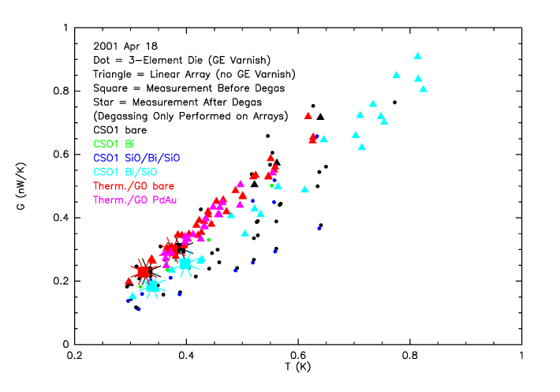
Figure 5: Type 2B Bolometer Thermal Conductance vs. Temperature

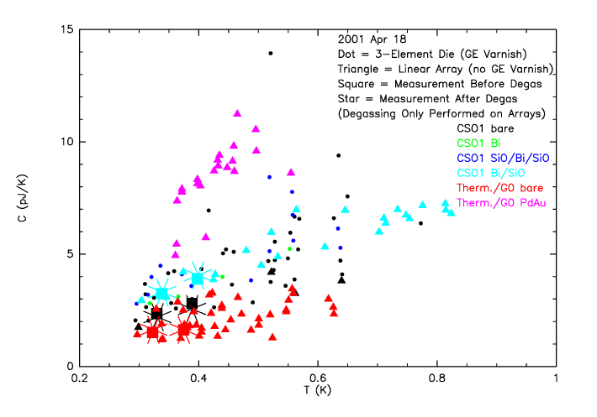
Figure 6: Type 2B Bolometer Heat Capacity vs. Temperature

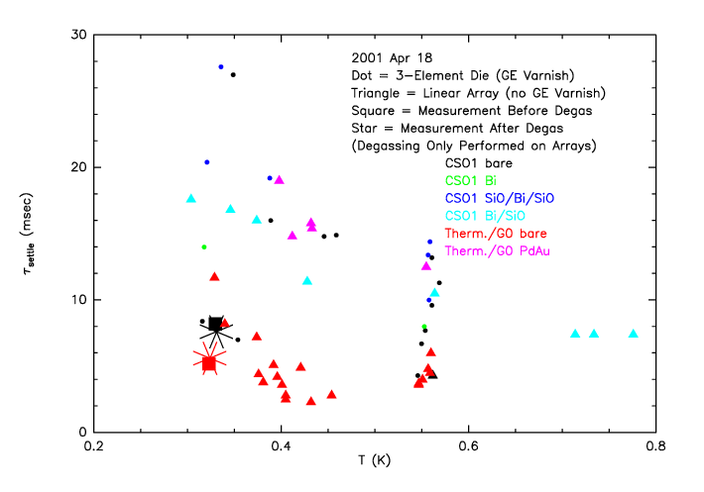
Figure 7: Type 2B Bolometer τ_{settle} vs. Temperature for V_{bias} ~ V_{opt}

Tables 1-4 summarize the stepped bias time constant measurements to date. Table 2 is restricted to devices of design type HGUNIT.2B, because that design is closest to that used in all CSO1 devices; Table 4 is restricted to devices of type HGUNIT.3? (where ? can be any letter from A to D) because these have been targeted as potentially better designs for use in HAWC. The results for the 5347.7500 LH3 thermistor array from July 2000 have not previously been reported.
In an effort to enhance comparison between measurement sets, all bolometer models used to generate the above tables were developed in an equivalent fashion. Specifically, each device’s model was generated from IV curves at only two temperatures. These two temperatures were chosen from available IV data so as to best “bracket” the range of T the device covered during the stepped bias measurements. While model extrapolation to match the actual range of T was avoided where possible, a small extrapolation (i.e. 100-200 mK) was preferred to a large “over-extension” of the model’s range. For most devices, the selected IV temperatures were ~300 and ~500 mK.
We take τ_{settle} to be a measurement of the effective bolometer time constant, τ_{e}. For all measurements, device models have been used to predict T, G, and τ_{e}/τ; these values are used with the measured τ_{settle} to calculate a value of C. Figures 4 and 5 show C and G as a function of bolometer temperature for each type HGUNIT.2B bolometer measured; Figure 6 shows τ_{settle} as a function of type HGUNIT.2B bolometer temperature for only those cases where V_{bias} ~ V_{opt}.
The following conclusions may be drawn:

- Comparison between otherwise equivalent devices shows that the addition of an absorbing film increases C. The magnitude of the change depends on the composition of the film – for our limited sample, the increase in C is a factor of ~ 4-5 for PdAu and ~ 1.1-2 for various combinations of Bi and SiO. To a lesser degree, there is also a decrease in G, at the level of ~ 5% for PdAu and ~ 3-30% for combinations of Bi and SiO. For CSO1 devices, the same type of film can have effects of different magnitudes, perhaps due only to variability in film application (it does not appear to be correlated with wafer doping). The cumulative effect of adding an absorbing layer, then, is a definitely slower bolometer.
- C is the determining parameter for τ that is most difficult to constrain. For CSO1 devices, G is generally the same while C varies greatly by wafer, leading to variations in τ by as much as a factor of 2; the same can be said for the test arrays. Also, Figures 4 and 5 demonstrate that across all devices, the variance in C is much larger than that in G.
- Variation in thermistor size does not appear to be a dominant factor in determination of τ, with an increase of only ~ 30% for the largest thermistor as compared to the smallest on wafer 5347Th RH7.
- Comparing type HGUNIT.2B bare bolometers at T ~ 350 mK, the CSO1 devices have τ >~ 10 msec, while those from the test arrays have τ ~ 2-5 msec. One reason for this is that G ~ .2 and .3 nW/K for most CSO1 and test array devices, respectively; however, this variation alone would predict only a 50% difference in τ. The additional difference appears due to the fact that CSO1 devices have C ~ 2-4 pJ/K, as compared to C ~ 1-2 pJ/K for the test arrays.
- Comparing bare bolometers on the 5347 LH1 G₀ test array at T ~ 350 mK, type HGUNIT.3? devices are on average ~ 3 times faster than type HGUNIT.2B; this decrease in τ_{settle} is due primarily to the HGUNIT.3? devices having a ~ 2.5 times larger G, with a small contribution from a ~ 40% smaller C. There is no noticeable difference in τ_{settle} between device types HGUNIT.3A and HGUNIT.3C, although the latter has G and C lower by ~ 20 and 10% on average, respectively; apparently the small design difference results only in a correlated scaling of G and C, leaving time constants fixed.
- The fastest devices from CSO1 (5273.7200 T1 and 5311.7000 T2/LH6) have nearly the same τ as the slowest HGUNIT.2B devices from the test arrays (5347Th LH3), with τ_{settle} ~ 8 msec at T ~ 300 mK for bare bolometers in each case.

Having seen that the CSO1 devices appear to be slower than those on the test arrays, we have attempted to vary aspects of the experimental setup to see if some systematic effect is being introduced to artificially raise these new time constants.
First, the 5347Th LH3 test array, tested in the SHARC II dewar in July 2000, was re-tested in the Barney dewar in December 2000. Bolometers 5 and 6 were measured in both cases, and in December they were found to be ~20-60% faster than in July, due primarily to a lower calculated C. These new values are more similar to those found for other test arrays, while newly measured bolometer 4 yields time constants similar to those found for bolometers 5 and 6 in July. Most likely, these spreads in measured time constants are reflective of the variance inherent in our measurements, but there is certainly no indication that the Barney dewar setup somehow tends to slow the detectors down.
Next, on January 10, 2001, two 16-element arrays – 5347^{G0} LH1 and 5311.7000 LH6 – were simultaneously measured in the Barney dewar. Arrays were chosen so that GE varnish would not be used, as it is possible that the varnish could be outgassing and contaminating the detectors. The inclusion of a partial test array provides another comparison to results from the spring of 2000. The newly measured time constants agree extremely well with previous results for both arrays – 5311.7000 LH6 is compared to the 3-element die T2, which is both physically closest on the wafer and closest in resistance (2.19 vs. 2.86 MΩ, respectively, for bare bolometers). They again follow the observed trend of test arrays being faster than CSO1 devices. Thus, it appears unlikely that GE varnish was in any way contaminating the previously tested CSO1 bolometers; there is also further reinforcement that the Barney dewar setup is not a factor.
An additional concern was that a helium leak inside the Barney dewar could be contaminating the bolometers. To test for this possibility, the bolometers were heated to above 5 K for 4 minutes by allowing 10-20 μA to run through them, in order to “de-gas” them. 30 minutes after this degassing (see notes for Tables 2 and 3), several bolometers were tested at T ~ 300 mK and compared to initial measurements with the same biasing conditions. In all cases, τ_{settle} was found to be no more than ~10% different after degassing, and was more likely to increase than decrease in our limited sample. It is most likely that these changes are reflective of measurement variance, as in the repeat measurements of the 5347Th LH3 array; small differences in T_{base} for the measurements being compared may also be a factor. In any event, it does not appear likely that helium contamination is a problem for any of the previous CSO1 measurements, either.
To date, no other sources of detector contamination or problems with the Barney dewar setup have been considered likely. While some such problem could possibly have been overlooked, it appears that the CSO Run 1 bolometers are genuinely slower than those from the initial test arrays. Whether this is due to any design changes or is just a property of the latest round of bolometer fabrication cannot yet be determined.

References

Mather, J. C. 1982, Applied Optics 21, 1125, “Bolometer noise: nonequilibrium theory”

