CSO Run 1 Bolometers: Time Constants, Addendum – Measurement Interpretation and Predicted Performance

Darren Dowell (Caltech)

Version: 7 February 2001

Summary

This report is a companion to M. Gardner’s “CSO Run 1 Bolometers: Time Constants” report. This report uses information from the Calibration Run and CSO Run 1 to make the best guess of the HAWC NEP and response time.

Heat Capacity Measurements

For the calculations and comparisons below, the heat capacity measurements (C vs. T of pixel) for a single bolometer are fit with a straight line, and the predictions of that linear model at 0.3 K, 0.4 K, and 0.5 K are tabulated. In most cases, the 0.3 K entry is an extrapolation.

1. Heat capacity of bare 2B.1 pixel – Calibration Run vs. CSO Run 1
The 2B.1 pixels have full area (0.90 mm x 0.99 mm) thermometers and 16 micron torsion bars.

Table 1a – Calibration Run, bare 2B.1 pixels
Array | Bolometer | C (0.3 K)  pJ/K | C (0.4 K)  pJ/K | C (0.5 K)  pJ/K
5347 G0 LH1 | 2 | 1.56 | 1.89 | 2.22
5347 G0 LH1 | 3 | 1.38 | 1.90 | 2.42
5347 G0 LH1 | 4 | 1.12 | 1.54 | 1.96
5347 Th RH7 | 23 | 1.55 | 1.89 | 2.23
5347 Th LH3 | 5 | 1.67 | 2.25 | 2.83
MEDIAN |  | 1.55 | 1.89 | 2.23

Table 1b – CSO Run 1, bare 2B.1 pixels
Array | Bolometer | C (0.3 K)  pJ/K | C (0.4 K)  pJ/K | C (0.5 K)  pJ/K
5045.7000 T4 * | right | 2.66 | 3.84 | 5.02
5273.7200 T1 * | right | 1.97 | 3.10 | 4.23
5273.7200 T2 * | mid | 3.04 ** | 4.59 ** | 6.13 **
5273.7200 T4 * | mid | 3.59 | 4.26 | 4.93
5311.7000 T2 * | right | 2.85 | 3.05 | 3.26
5311.7000 T4 * | right | 2.53 | 2.99 | 3.45
5311.7000 LH6 | 5 | 2.08 | 2.68 | 3.27
MEDIAN |  | 2.66 | 3.10 | 4.23
* Attached with GE varnish.
** Omitted 2 measurements well above best fit line. This lowered tabulated entries approximately 10%.

CONCLUSION: The median heat capacities for CSO Run 1 are 1.6-1.9 times those for the Calibration Run, depending on the temperature of comparison. An optimist would remark that the CSO Run 1 sample with the lowest heat capacity was the only 32-element array and the only one attached without GE varnish. The heat capacity of that sample was 1.3-1.5 times the median of the Calibration Run.

2. Heat capacity vs. thermistor size – Calibration Run

Table 2a – Calibration Run, bare 2B pixels with smaller thermistors
Array | Bol. | Type | Thermistor Area (mm²) | C (0.3 K)  pJ/K | C (0.4 K)  pJ/K | C (0.5 K)  pJ/K
5347 Th RH7 | 10 | 2B4 | 0.12 x 0.08 | 1.15 | 1.36 | 1.58
5347 Th LH3 | 4 | 2B2 | 0.23 x 0.16 | 1.29 | 2.46 | 3.64
5347 G0 LH1 | 24 | 2B | 0.94 x 0.65 | 1.31 | 1.27 | 1.24
5347 Th LH3 | 6 | 2B | 0.94 x 0.65 | 2.29 | 2.58 | 2.87

Table 2b – Calibration Run, bare 2B pixels with smaller thermistors compared to 2B.1
Array | Bol. | Type | Thermistor Area (mm²) | Comp. Bol. | C (0.3 K)  Ratio | C (0.4 K)  Ratio | C (0.5 K)  Ratio
5347 Th RH7 | 10 | 2B4 | 0.12 x 0.08 | 23 | 0.74 | 0.72 | 0.71
5347 Th LH3 | 4 | 2B2 | 0.23 x 0.16 | 5 | 0.77 | 1.09 | 1.29
5347 G0 LH1 | 24 | 2B | 0.94 x 0.65 | 3 | 0.95 | 0.67 | 0.51
5347 Th LH3 | 6 | 2B | 0.94 x 0.65 | 5 | 1.37 | 1.15 | 1.01
Comp. Bol. – comparison 2B.1 bolometer with which heat capacity is ratioed.

CONCLUSION: Some measurements of the bolometers with smaller thermistors appear to have lower quality, as implied by the unusual temperature dependence of the heat capacities in 5347 G0 LH1 bol. 24 (no T dependence) and 5347 Th LH3 bol. 4 (steep T dependence). Also, the number of measured bolometers is small, so it is difficult to draw firm conclusions. However, for the two bolometers with the smallest thermistors, the heat capacity was only at best 30% lower compared to full area thermistors.

3. Heat capacity of bare 3C and 3A pixels – Calibration Run
The 3C and 3A bolometers both have 40 micron torsion bars and 0.94 mm x 0.65 mm thermistors. Type 3C has no metal on the torsion bar, and type 3A has metal on the half of the torsion bar away from the pixel.

Table 3 – Calibration Run, bare 3C and 3A pixels with smaller thermistors
Array | Bol. | Type | C (0.3 K)  pJ/K | C (0.4 K)  pJ/K | C (0.5 K)  pJ/K
5347 G0 LH1 | 8 | 3C | 0.74 | 1.23 | 1.72
5347 G0 LH1 | 9 | 3C | 0.70 | 1.26 | 1.81
5347 G0 LH1 | 10 | 3C | 0.83 | 1.35 | 1.86
5347 G0 LH1 | 14 | 3A | 0.85 | 1.41 | 1.97
5347 G0 LH1 | 15 | 3A | 0.98 | 1.31 | 1.65
MEDIAN |  |  | 0.83 | 1.31 | 1.81

CONCLUSION: The measured heat capacity of these devices is 0.5 – 0.8 times the median heat capacity of the 2B.1 devices from the Calibration Run, and 0.7 – 0.9 times the median heat capacity of the 2B devices. I can’t think of a reason why the heat capacity should be much different.

4. Heat capacity of bismuth absorber – CSO Run 1
In this section, we attempt to separate the heat capacity of bismuth absorbing films from that of the underlying pixel.

Table 4 – CSO Run 1, type 2B.1 pixels with bismuth absorbers
Array | Bol. | Absorber | Comp. Bol. | C (0.3 K)  Difference  pJ/K | C (0.4 K)  Difference  pJ/K | C (0.5 K)  Difference  pJ/K
5311.7000 T2 * | left | Bi | right | -0.32 | 0.54 | 1.39
5311.7000 LH6 | 2 | Bi/SiO | 5 | 0.73 | 1.47 | 2.23
5311.7000 LH6 | 3 | Bi/SiO | 5 | 0.57 | 0.93 | 1.31
MEDIAN |  | Bi/SiO |  | 0.65 | 1.20 | 1.77
5045.7000 T4 * | left | SiO/Bi/SiO | right | 2.32 | 1.84 | 1.36
5273.7200 T1 * | left | SiO/Bi/SiO | right | 1.14 | 1.81 | 2.48
5311.7000 T4 * | left | SiO/Bi/SiO | right | 0.48 | 0.80 | 1.12
MEDIAN |  | SiO/Bi/SiO |  | 1.14 | 1.81 | 1.36
Absorber details: Bi = 50 ohms/square RT Bi; Bi/SiO = 1000 angstroms Bi + 1000 angstroms SiO; SiO/Bi/SiO = 1000 angstroms SiO + 60 ohms/square RT Bi + 1000 angstroms SiO.
Comp. Bol. = comparison bolometer used for subtraction of bare pixel heat capacity.
* Attached with GE varnish.

CONCLUSION: The bismuth/SiO film clearly adds a heat capacity to the pixel. For the Bi/SiO design, the additional heat capacity is 0.7, 1.2, and 1.8 pJ/K at 0.3, 0.4, and 0.5 K, respectively.

Thermal Conductance Measurements

For the calculations and comparisons below, we tabulate the thermal conductance G at 0.3 K, 0.4 K, and 0.5 K using the bolometer models derived from the IV measurements.

5. Thermal conductance of bare 2B.1 pixel – Calibration Run vs. CSO Run 1
The 2B.1 pixels have full area (0.90 mm x 0.99 mm) thermometers and 16 micron torsion bars.

Table 5a – Calibration Run, bare 2B.1 pixels
Array | Bolometer | G (0.3 K)  nW/K | G (0.4 K)  nW/K | G (0.5 K)  nW/K
5347 G0 LH1 | 2 | 0.21 | 0.32 | 0.45
5347 G0 LH1 | 3 | 0.20 | 0.33 | 0.49
5347 G0 LH1 | 4 | 0.22 | 0.34 | 0.49
5347 Th RH7 | 23 | 0.25 | 0.37 | 0.51
5347 Th LH3 | 5 | 0.21 | 0.33 | 0.47
MEDIAN |  | 0.21 | 0.33 | 0.49
Table 5b – CSO Run 1, bare 2B.1 pixels
Array | Bolometer | G (0.3 K)  nW/K | G (0.4 K)  nW/K | G (0.5 K)  nW/K
5045.7000 T4 * | right | 0.21 | 0.34 | 0.51
5273.7200 T1 * | right | 0.19 | 0.32 | 0.48
5273.7200 T2 * | mid | 0.11 | 0.20 | 0.31
5273.7200 T4 * | mid | 0.14 | 0.24 | 0.35
5311.7000 T2 * | right | 0.23 | 0.38 | 0.57
5311.7000 T4 * | right | 0.11 | 0.17 | 0.25
5311.7000 LH6 | 5 | 0.19 | 0.32 | 0.47
MEDIAN |  | 0.19 | 0.32 | 0.47
* Attached with GE varnish.

CONCLUSION: The thermal conductance of the median CSO Run 1 device is about 0.94 times that of the Calibration Run devices. There is a range of a factor of 2 in the CSO Run 1 measurements.

6. Thermal conductance vs. thermistor size – Calibration Run

Table 6a – Calibration Run, bare 2B pixels with smaller thermistors
Array | Bol. | Type | Thermistor Area (mm²) | G (0.3 K)  nW/K | G (0.4 K)  nW/K | G (0.5 K)  nW/K
5347 Th RH7 | 10 | 2B4 | 0.12 x 0.08 | 0.21 | 0.34 | 0.49
5347 Th LH3 | 4 | 2B2 | 0.23 x 0.16 | 0.19 | 0.31 | 0.46
5347 G0 LH1 | 24 | 2B | 0.94 x 0.65 | 0.23 | 0.34 | 0.46
5347 Th LH3 | 6 | 2B | 0.94 x 0.65 | 0.20 | 0.33 | 0.47

Table 6b – Calibration Run, bare 2B pixels with smaller thermistors compared to 2B.1
Array | Bol. | Type | Thermistor Area (mm²) | Comp. Bol. | G (0.3 K)  Ratio | G (0.4 K)  Ratio | G (0.5 K)  Ratio
5347 Th RH7 | 10 | 2B4 | 0.12 x 0.08 | 23 | 0.84 | 0.92 | 0.96
5347 Th LH3 | 4 | 2B2 | 0.23 x 0.16 | 5 | 0.90 | 0.94 | 0.98
5347 G0 LH1 | 24 | 2B | 0.94 x 0.65 | 3 | 1.15 | 1.03 | 0.94
5347 Th LH3 | 6 | 2B | 0.94 x 0.65 | 5 | 0.95 | 1.00 | 1.00
Comp. Bol. – comparison 2B.1 bolometer with which thermal conductance is ratioed.

CONCLUSION: We do not expect the thermal conductance to depend on thermistor size. There is no strong suggestion of a dependence.

7. Thermal conductance of bare 3C and 3A pixels – Calibration Run
The 3C and 3A bolometers both have 40 micron torsion bars and 0.94 mm x 0.65 mm thermistors. Type 3C has no metal on the torsion bar, and type 3A has metal on the half of the torsion bar away from the pixel.

Table 7 – Calibration Run, bare 3C and 3A pixels with smaller thermistors
Array | Bol. | Type | G (0.3 K)  nW/K | G (0.4 K)  nW/K | G (0.5 K)  nW/K
5347 G0 LH1 | 8 | 3C | 0.50 | 0.78 | 1.10
5347 G0 LH1 | 9 | 3C | 0.51 | 0.79 | 1.11
5347 G0 LH1 | 10 | 3C | 0.51 | 0.82 | 1.18
MEDIAN |  |  | 0.51 | 0.79 | 1.11
5347 G0 LH1 | 14 | 3A | 0.70 | 1.15 | 1.70
5347 G0 LH1 | 15 | 3A | 0.69 | 1.09 | 1.54
MEDIAN |  |  | 0.70 | 1.12 | 1.62

CONCLUSION: Type 3A has 1.4 times the thermal conductance of type 3C. Type 3C has 2.4 times the thermal conductance of type 2B.1.

8. Thermal conductance of pixels with bismuth absorber – CSO Run 1
In this section, we attempt to constrain the possible change in thermal conductance due to application of the absorber.

Table 8 – CSO Run 1, type 2B.1 pixels with bismuth absorbers
Array | Bol. | Absorber | Comp. Bol. | G (0.3 K)  Ratio | G (0.4 K)  Ratio | G (0.5 K)  Ratio
5311.7000 T2 * | left | Bi | right | 0.70 | 0.74 | 0.74
5311.7000 LH6 | 2 | Bi/SiO | 5 | 0.79 | 0.81 | 0.83
5311.7000 LH6 | 3 | Bi/SiO | 5 | 0.68 | 0.72 | 0.77
MEDIAN |  | Bi/SiO |  | 0.74 | 0.77 | 0.80
5045.7000 T4 * | left | SiO/Bi/SiO | right | 0.81 | 0.82 | 0.82
5273.7200 T1 * | left | SiO/Bi/SiO | right | 0.74 | 0.75 | 0.77
5311.7000 T4 * | left | SiO/Bi/SiO | right | 0.91 | 1.00 | 0.96
MEDIAN |  | SiO/Bi/SiO |  | 0.81 | 0.82 | 0.82
Absorber details: Bi = 50 ohms/square RT Bi; Bi/SiO = 1000 angstroms Bi + 1000 angstroms SiO; SiO/Bi/SiO = 1000 angstroms SiO + 60 ohms/square RT Bi + 1000 angstroms SiO.
Comp. Bol. = comparison bolometer used for ratio of bare pixel thermal conductance.
* Attached with GE varnish.

CONCLUSION: Somewhat surprisingly, the absorber reduces the apparent thermal conductance by 20-30%.

Predicted Time Constants and NEP’s for Revised HAWC Bolometers

Best guess for thermal conductance
For 2B.1 design, G(0.3 K) = 0.19 nW/K (CSO Run 1 bare) × 0.74 (absorber correction) = 0.14 nW/K. Similarly, G(0.4 K) = 0.25 nW/K and G(0.5 K) = 0.38 nW/K. This is approximated by G (nW/K) = 1.49 × T^{1.96}.
For 3C design with full area thermometer, G(0.3 K) = 0.51 nW/K (CSO Run 1 bare) × 0.74 (absorber correction) = 0.38 nW/K. Similarly, G(0.4 K) = 0.61 nW/K and G(0.5 K) = 0.89 nW/K. This is approximated by G (nW/K) = 2.82 × T^{1.66}.

Best guess for heat capacity
For both designs, C(0.3 K) = 2.66 pJ/K (CSO Run 1 bare) + 0.65 pJ/K (absorber) = 3.31 pJ/K. Similarly, C(0.4 K) = 4.30 pJ/K and C(0.5 K) = 6.00 pJ/K. This is approximated by C (pJ/K) = 13.0 × T^{1.15}.

Additional assumptions
From the HAWC CDR: T(base) = 0.2 K. Load resistor is 400 MΩ at 4.2 K. R(T) = 1300 Ω exp(sqrt(30 K/T)). Full area thermometer (0.99 mm × 0.90 mm × 3000 Å). Amplifier voltage noise = 6 nV Hz^{-1/2}, current noise = 0. Background power and noise are a) 60 pW, 6.6 × 10⁻¹⁶ W Hz^{-1/2}; b) 20 pW, 2.2 × 10⁻¹⁶ W Hz^{-1/2}. Frequency = 5 Hz.

NEP and time constant predictions for HAWC
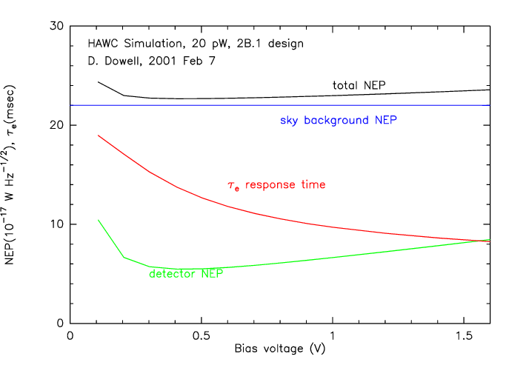
Figure 1
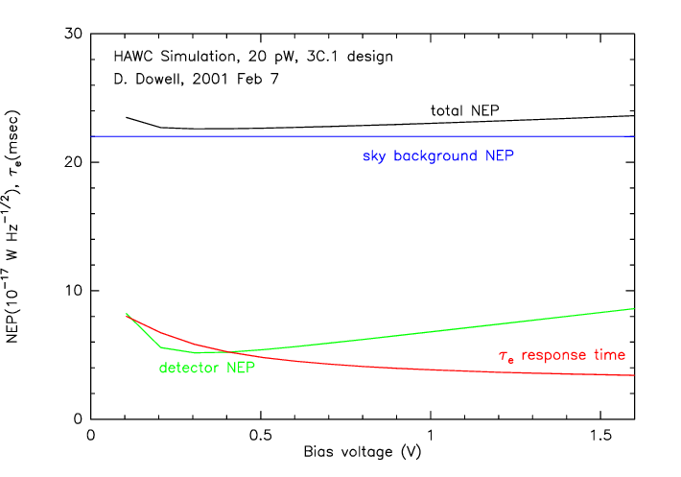
Figure 2
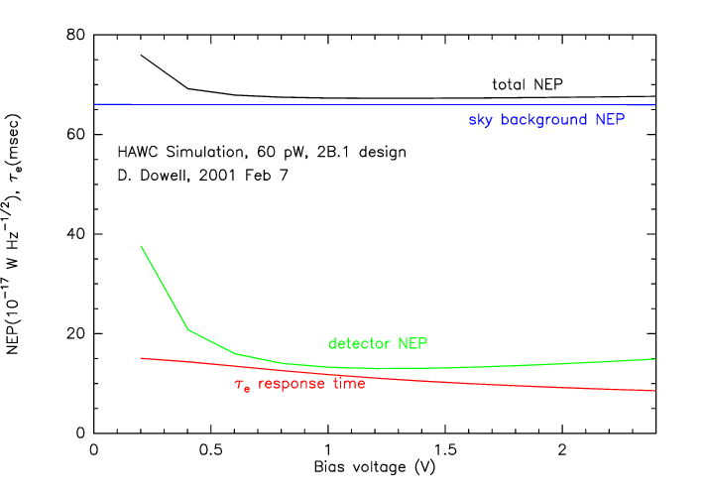
Figure 3

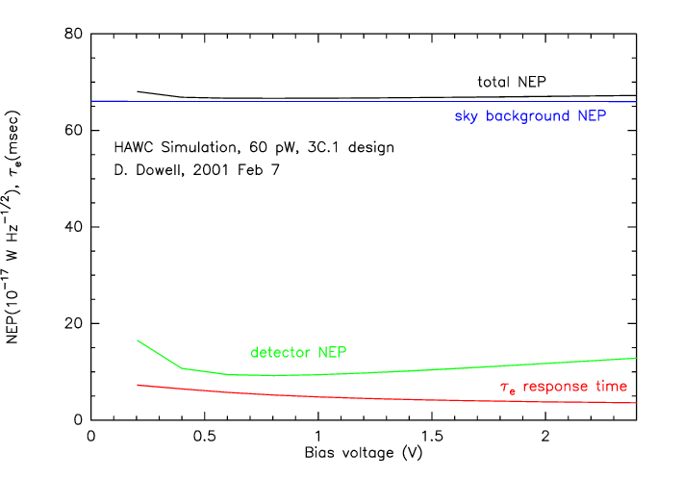
Figure 4

Note 1: The graphed NEP does not take into account the degradation due to the time constant.

Note 2: One might be able to do a little better by re-optimizing the resistance target.

