Test Report – Three-Bolometer Devices from
CSO Run 1

C. Darren Dowell (Caltech)
Version: 20 December 2000 (slight correction 20 September 2001)

Acknowledgments

Christine Allen (NASA/GSFC) provided the bolometers. Jeff Groseth (Caltech) glued and wirebonded the dies. Matt Gardner (Caltech) performed the majority of the measurements.

Apparatus

Cryostat: Caltech Barney Dewar, which is IR Labs HDL-10 with helium shield + Chase Research single-stage ³He fridge. RFI filtered connectors with 1-4 nF capacitance.

Detector holder: Up to 6 each 10 mm × 8 mm dies attached with GE varnish to fiberglass PC board with gold-plated copper traces. PC board screwed to Invar base and covered with lid. Black paint on inside of lid. Invar base attached with screws and N grease to copper cradle, which is attached to fridge coldhead with screws and N grease. Eight each gold wirebonds (0.001”) provide electrical interface to each die. Calibrated Lakeshore G.R.T. attached to PC board with screw and N grease.

Methods: Resistance measurements were taken at approximately 2 K, 0.5 K, and 0.3 K, and in some cases 4 K and 0.35 K. 1) Current applied through bolometer in series with one of four room temperature load resistors (310 MΩ, 20 MΩ, 1 MΩ, 0.1 MΩ) and measured with Keithley 487 picoammeter. Total voltage across load resistor/bolometer measured with HP 34401A multimeter. 2) Load resistors and JFETs inside Dewar used during measurements. Bias voltage switched at ~1 Hz from 0 to a range of voltages. Signal recorded with A/D and DSP. Bolometer V is obtained directly from amplitude, and bolometer I is calculated from bias voltage, bolometer V, and load resistance.

Measurement period: All measurements took place between 2000 Nov. 10 and 2000 Dec. 6.

During the Nov. 11 cooldown, we measured a bare bolometer on die 2041 T3 and one coated with 1000 Å silver. At 0.282 K, the resistances were 130 MΩ and 120 MΩ respectively. During the Nov. 14 cooldown, we measured a bare bolometer on die 5311 T3 and one coated with 1000 Å silver. At 0.281 K, the resistances were 146 MΩ and 126 MΩ respectively. Therefore, for the purposes of measurements of bolometers without absorbers, the detector enclosure is dark and free of RFI heating.

During the Nov. 24 cooldown, we measured a bare bolometer on die 2041 T2 and one coated with a bismuth absorber. At 0.287 K, the resistances were 82 MΩ and 68 MΩ respectively. We also measured a bare bolometer on die 5311 T2 and one coated with bismuth. At 0.287 K, the resistances were 35 MΩ and 29 MΩ respectively. These results alone could imply that a light leak is warming the bolometers with absorbers. However, this hypothesis does not result in a good fit to the measurements including other temperatures. We suspect that the application of a metal film to the back side of the bolometers results in a measurable decrease in resistance, since this has now been observed in 4 out of 4 cases. (NEEDS UPDATING – EFFECT IS STILL THERE.)

Thermistor Measurements

The thermistor behavior is modeled as R = R₀ exp(sqrt(Δ/T)). Sample measurements from November 10-11 are shown in the figures below:

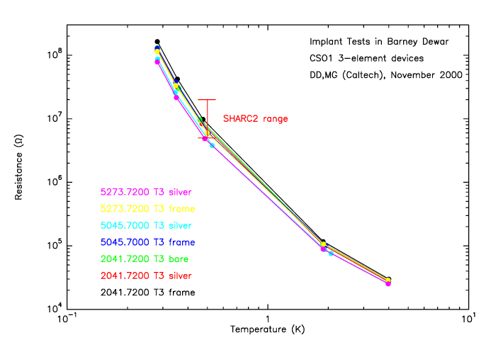
Figure 1 – Resistance vs. temperature for 3 dies.

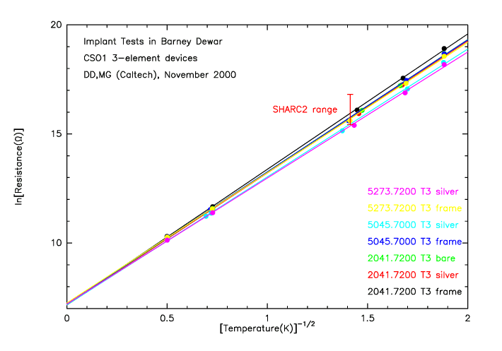
Figure 2 – Resistance vs. temperature shown in units which are expected to have a linear relation.

Table 1 – Resistance Measurements
Die | Thermistor Type | Bol.  Loc. | Date | Meth. | Δ  K | R₀  Ω | R (0.5 K)  MΩ
5045.7000 T1 | bare bolometer | mid | Dec. 6 | 2 | 24.7 | 1602 | 1.80
5045.7000 T1 | bare bolometer | right | Dec. 6 | 2 | 24.7 | 1599 | 1.80
5045.7000 T2 | bare bolometer | right | Nov. 24 | 1 | 28.4 | 1412 | 2.65
5045.7000 T2 | bare bolometer | right | Nov. 26 | 2 | 26.0 | 1839 | 2.48
5045.7000 T3 | bolometer w/ Ag | right | Nov. 11 | 1 | 34.4 | 1292 | 5.15
5045.7000 T4 | w/ SiO/Bi/SiO | left | Dec. 19 | 2 | 38.3 | 1193 | 7.58
5045.7000 T4 | bare bolometer | right | Dec. 19 | 2 | 38.9 | 1161 | 7.90
5311.7000 T2 | bolometer w/ Bi | left | Nov. 24 | 1 | 28.2 | 1442 | 2.64
5311.7000 T2 | bolometer w/ Bi | left | Dec. 16 | 2 | 28.3 | 1513 | 2.81
5311.7000 T2 | bare bolometer | right | Nov. 24 | 1 | 29.4 | 1363 | 2.93
5311.7000 T2 | bare bolometer | right | Nov. 26 | 2 | 28.8 | 1508 | 2.98
5311.7000 T2 | bare bolometer | right | Dec. 16 | 2 | 29.4 | 1433 | 3.05
5311.7000 T3 | bare bolometer | left | Nov. 14 | 1 | 38.3 | 1212 | 7.67
5311.7000 T3 | bolometer w/ Ag | right | Nov. 14 | 1 | 37.4 | 1187 | 6.73
5311.7000 T4 | w/ SiO/Bi/SiO | left | Dec. 16 | 2 | 36.6 | 1302 | 6.80
5311.7000 T4 | bare bolometer | right | Dec. 16 | 2 | 37.4 | 1231 | 7.04
2041.7200 T2 | bare bolometer | right | Nov. 24 | 1 | 35.0 | 1239 | 5.33
2041.7200 T2 | bare bolometer | right | Nov. 26 | 2 | 34.1 | 1425 | 5.49
2041.7200 T2 | bolometer w/ Bi | left | Nov. 24 | 1 | 33.6 | 1302 | 4.74
2041.7200 T3 | bare bolometer | left | Nov. 11 | 1 | 36.8 | 1327 | 7.03
2041.7200 T3 | bolometer w/ Ag | right | Nov. 11 | 1 | 36.6 | 1283 | 6.68
5251.7200 T3 | bolometer w/ Ag | right | Nov. 16 | 1 | 30.5 | 1441 | 3.57
5251.7200 T4 | bare bolometer | mid | Dec. 6 | 2 | 32.0 | 1560 | 4.63
5251.7200 T4 | bare bolometer | right | Dec. 6 | 2 | 33.2 | 1305 | 4.54
5273.7200 T1 | w/ SiO/Bi/SiO | left | Dec. 19 | 2 | 25.0 | 1564 | 1.83
5273.7200 T1 | bare bolometer | right | Dec. 19 | 2 | 25.4 | 1503 | 1.87
5273.7200 T2 | bare bolometer | mid | Dec. 1 | 2 | 29.8 | 1492 | 3.37
5273.7200 T3 | bolometer w/ Ag | right | Nov. 11 | 1 | 33.3 | 1342 | 4.72
5273.7200 T4 | bare bolometer | mid | Dec. 6 | 2 | 35.1 | 1398 | 6.12
5332.7200 T3 | bolometer w/ Ag | right | Nov. 16 | 1 | 24.2 | 1525 | 1.60
5350.7200 T2 | bare bolometer | mid | Dec. 1 | 2 | 34.0 | 1317 | 4.99
5350.7200 T4 | bolometer w/ Ag | right | Nov. 16 | 1 | 29.0 | 1523 | 3.08
2042.7375 T3 | bolometer w/ Ag | right | Nov. 16 | 1 | 17.8 | 1764 | 0.69
5326.7375 T3 | bolometer w/ Ag | right | Nov. 14 | 1 | 19.0 | 1690 | 0.80
5330.7375 T2 | bare bolometer | mid | Dec. 1 | 2 | 25.4 | 1525 | 1.89
5330.7375 T3 | bolometer w/ Ag | right | Nov. 14 | 1 | 29.2 | 1362 | 2.85
5045.7000 T1 | frame |  | Dec. 6 | 2 | 25.3 | 1665 | 2.05
5045.7000 T2 | frame |  | Nov. 24 | 1 | 29.4 | 1425 | 3.05
5045.7000 T2 | frame |  | Nov. 26 | 2 | 28.6 | 1594 | 3.05
5045.7000 T3 | frame |  | Nov. 11 | 1 | 36.6 | 1345 | 7.02
5045.7000 T4 | frame |  | Dec. 19 | 2 | 39.7 | 1153 | 8.58
5311.7000 T2 | frame |  | Nov. 24 | 1 | 30.8 | 1370 | 3.49
5311.7000 T2 | frame |  | Nov. 26 | 2 | 30.4 | 1470 | 3.57
5311.7000 T2 | frame |  | Dec. 16 | 2 | 30.4 | 1402 | 3.43
5311.7000 T3 | frame |  | Nov. 14 | 1 | 40.7 | 1140 | 9.44
5311.7000 T4 | frame |  | Dec. 16 | 2 | 37.6 | 1232 | 7.20
2041.7200 T2 | frame |  | Nov. 24 | 1 | 35.7 | 1248 | 5.80
2041.7200 T2 | frame |  | Nov. 26 | 2 | 34.9 | 1368 | 5.84
2041.7200 T3 | frame |  | Nov. 11 | 1 | 38.5 | 1300 | 8.42
5251.7200 T3 | frame |  | Nov. 16 | 1 | 34.7 | 1342 | 5.58
5251.7200 T4 | frame |  | Dec. 6 | 2 | 34.0 | 1277 | 4.87
5273.7200 T1 | frame |  | Dec. 19 | 2 | 25.9 | 1511 | 2.01
5273.7200 T2 | frame |  | Dec. 1 | 2 | 31.9 | 1386 | 4.08
5273.7200 T3 | frame |  | Nov. 11 | 1 | 35.7 | 1405 | 6.54
5273.7200 T4 | frame |  | Dec. 6 | 2 | 35.9 | 1334 | 6.35
5332.7200 T3 | frame |  | Nov. 16 | 1 | 27.2 | 1567 | 2.50
5350.7200 T2 | frame |  | Dec. 1 | 2 | 35.2 | 1253 | 5.52
5350.7200 T4 | frame |  | Nov. 16 | 1 | 32.9 | 1375 | 4.57
2042.7375 T3 | frame |  | Nov. 16 | 1 | 19.0 | 1839 | 0.87
5326.7375 T3 | frame |  | Nov. 14 | 1 | 19.9 | 1765 | 0.98
5330.7375 T2 | frame |  | Dec. 1 | 2 | 27.0 | 1486 | 2.31
5330.7375 T3 | frame |  | Nov. 14 | 1 | 32.0 | 1321 | 3.92

All of the bolometer Δ’s are below the SHARC II target of 40 K. The R₀’s are nearly equal to the target of 1300 Ω. All of the values of R (0.5 K) undershoot the target of 10 MΩ, but 7 out of 22 dies have bolometers with R (0.5 K) above the SHARC II minimum of 5 MΩ.

The frame thermometers on average have a Δ higher by 1.7 K(?), an R₀ lower by a factor of 1.04(?), and an R (0.5 K) higher by a factor of 1.20(?) compared to the free-standing bare bolometers. Based on the thermistor geometry, we would expect a frame thermometer to have a higher R₀ by a factor of 1.05(?).

Wafer Selection for SHARC II

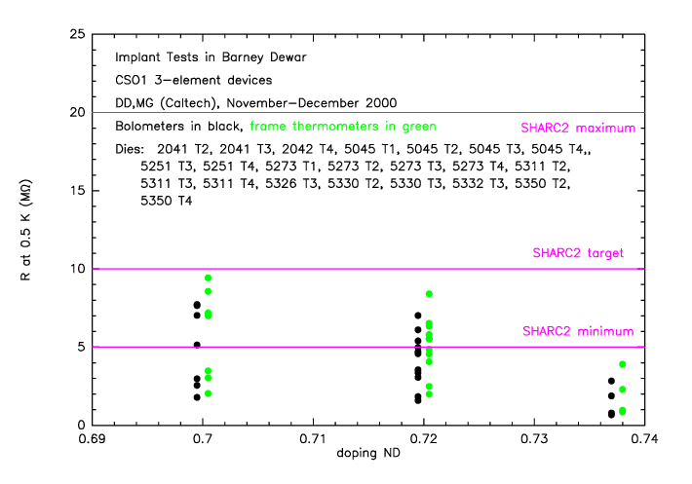
Figure 3 – R(0.5 K) vs. doping for the 19 measured dies.

Table 2 – SHARC II Candidate Wafers from CSO Run 1, with R at 0.5 K
Wafer | R(T1) | R(T2) | R(T3) | R(T4) | average | range ΔR
2041.7200 |  | 5.08 | 6.86 |  | 5.97 | 1.78
5311.7000 |  | 2.86 | 7.20 | 6.92 | 5.66 | 4.34
5045.7000 | 1.80 | 2.57 | 5.15 | 7.74 | 4.32 | 5.94
5251.7200 |  |  | 3.57 | 4.59 | 4.08 | 1.02
5350.7200 |  | 4.99 |  | 3.08 | 4.04 | 1.91
5273.7200 | 1.85 | 3.37 | 4.72 | 6.12 | 4.02 | 4.27
Resistance (MΩ) at 0.5 K of bolometers from SHARC II candidate wafers. The SHARC II target is 10 MΩ.

Wafer 2041 is the best candidate for building SHARC II, with 5311 as a second choice. It is likely that many elements from both wafers will have resistances below the SHARC II minimum which was established earlier in the year. Therefore, we tabulate below the effects of revising the SHARC II minimum downward. Assumptions not stated here are drawn from ‘HAWC and SHARC II Detector Recipe Requirements Document’, version 4, written by M. Freund. Q = 75 pW is the original background power estimate; Q = 120 pW is now considered more likely.

Table 3 – Effect on Sensitivity of Lowering SHARC II Resistance Requirement
 | Δ = 40 K,  R(0.5 K) =  10 MΩ | Δ = 35 K,  R(0.5 K) =  5.6 MΩ | Δ = 30 K,  R(0.5 K) =  3.0 MΩ
Q = 75 pW, f = 0.03 Hz (scanning) | 1.073 | 1.076 | 1.087
Q = 75 pW, f = 3 Hz (chopping) | 1.041 | 1.048 | 1.062
Q = 120 pW, f = 0.03 Hz (scanning) | 1.064 | 1.072 | 1.091
Q = 120 pW, f = 3 Hz (chopping) | 1.045 | 1.056 | 1.077
The tabulated quantity is NEP(total)/NEP(sky), where NEP(sky) is the fundamental atmospheric limit.

Table 4 – HAWC Candidate Wafers from CSO Run 1, with R at 0.35 K
Wafer | R(T1) | R(T2) | R(T3) | R(T4) | average | range ΔR
5045.7000 | 7.1 | 10.8 | 26.0 | 43.1 | 21.8 | 36.0
5273.7200 | 7.4 | 15.2 | 23.3 | 31.4 | 19.3 | 24.0
5350.7200 |  | 25.0 |  | 13.6 | 19.3 | 11.4
5251.7200 |  |  | 16.4 | 22.2 | 19.3 | 5.8
5330.7375 |  | 7.6 | 12.7 |  | 10.2 | 5.1
5332.7200 |  |  | 6.2 |  | 6.2 | na
Resistance (MΩ) at 0.35 K of bolometers from HAWC candidate wafers. The HAWC target is 13.5 MΩ.

Thermal Conductances

If enough current is applied to the thermistors, the resistance decreases due to heating. If the thermistor R(T) is known, the thermal conductance can be derived. This measurement was performed for the subset of thermistors measured November 11-14, and the results are reported in the table below. The thermal conductance is modeled as G = G₀T^{β}.

Table 4 – Measured Thermal Conductances
Die | Substrate Attachment* | Thermistor Type | G₀  nW K^{-1-β} | β | G (0.5 K)  nW/K
2041.7200 T3 | direct | bare bolometer | 1.62 | 1.98 | 0.41
5311.7000 T3 | isolated | bare bolometer | 1.91 | 1.95 | 0.49
2041.7200 T3 | direct | bolometer w/ Ag | 25.8 | 1.29 | 10.5
5045.7000 T3 | direct | bolometer w/ Ag | 40.9 | 1.36 | 15.9
5273.7200 T3 | isolated | bolometer w/ Ag | 35.8 | 1.18 | 15.8
5311.7000 T3 | isolated | bolometer w/ Ag | 29.6 | 1.36 | 11.6
5326.7375 T3 | direct | bolometer w/ Ag | 65.4 | 1.25 | 27.4
5330.7375 T3 | isolated | bolometer w/ Ag | 49.2 | 1.01 | 24.4
2041.7200 T3 | direct | frame | 1510 | 3.71 | 115
5045.7000 T3 | direct | frame | 24900 | 4.63 | 1010
5273.7200 T3 | isolated | frame | 1750 | 4.31 | 88.3
5311.7000 T3 | isolated | frame | 1050 | 3.74 | 78.8
5326.7375 T3 | direct | frame | 8640 | 2.95 | 1120
5330.7375 T3 | isolated | frame | 1900 | 2.68 | 296
* Direct: die/GE varnish/PCB. Isolated: die/GE varnish/perf. board/Stycast/PCB

The thermal conductance of the bare bolometers is comparable to the design goal (G = 0.57 nW/K at 0.5 K). The 1000 Å silver on the back increases the thermal conductance by more than an order of magnitude. The dies themselves are heatsunk with a G another order of magnitude higher, as inferred from the frame thermometers.

