JFET Warm Boards for HAWC and SHARC II –
Measured Performance and Optimization

D. Dowell, M. Gardner, J. Groseth
Caltech
2001 September 10

Synopsis

Caltech populated seven JFET “warm boards” for HAWC and SHARC II (serial numbers 1, 2, 3, 5, 6, 8, 9), each containing 128 JFETs, 6 heater resistors, and 2 diode thermometers. At the time of measurement, all boards passed the characterization criteria established before assembly. The JFET noise performance can be improved with modifications to the amplifier circuit used for the warm board characterization. The tabulated JFET noise supplied with each warm board is somewhat overestimated – especially at low frequencies – due to excess noise on the source voltage supply.

Circuit used for warm board characterization

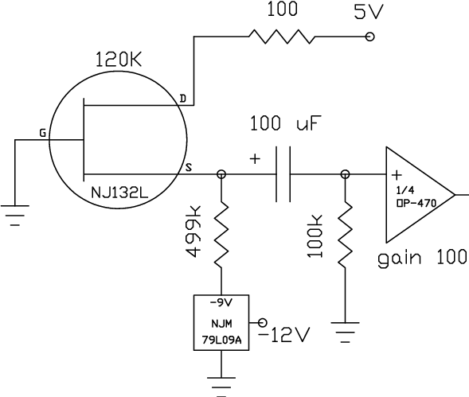
Figure 1 – JFET and amplifier circuit. The current for 32 JFETs is supplied by one shared drain regulator and 100 Ω resistor, one shared -9V regulator, and 32 each 499 kΩ resistors. This circuit gives acceptable, but not optimum, performance. The actual drain voltage is 4.94 V due to the voltage drop across the 100 Ω resistor.

The regulated source voltage supply (-9 V) could be eliminated by simply connecting the 499 kΩ resistor to the negative battery supply. However, in that case the JFET operating conditions and power dissipation would change as the battery is drained.

Measurement results

The warm boards were measured at approx. 120 K at Caltech. Each board went through a few temperature cycles as poorly operating devices were identified, replaced, and remeasured. The noise was measured at 120 K ± 10 K, and the DC parameters were measured at 120 K ± 1 K.

 | median | noise | (nV Hz^{-1/2}) | failed | failed | failed | source V | median
board | 3 Hz | 10 Hz | 30 Hz | strict | loose | DC | (mV) | DC gain
1 | 8.85 | 4.89 | 3.96 | 1 | 0 | 0 | [543, 593] | 0.996
2 | 8.76 | 4.73 | 3.79 | 0 | 0 | 0 | [513, 560] | 0.996
3 | 8.81 | 4.97 | 3.82 | 1 | 1 | 0 | [473, 524] | 0.996
5 | 8.38 | 4.74 | 3.69 | 0 | 0 | 0 | [448, 481] | 0.996
6 | 8.72 | 5.02 | 3.71 | 0 | 0 | 0 | [413, 457] | 0.996
8 | 9.23 | 5.10 | 3.82 | 1 | 0 | 0 | [369, 464] | 0.996
9 | 8.71 | 4.94 | 3.80 | 2 | 0 | 0 | [464, 591] | 0.996
Table 1 – Measured results for JFET warm boards. The JFET noise is overestimated in this table.

In Table 1, the tabulated noise has been corrected for the noise of the amplifier; the amplifier noise was measured with grounded inputs, and a median of the (similar) amplifier channels was subtracted in quadrature from the observed JFET + amplifier noise. “Failed strict” refers to the number of JFETs which had noise in excess of 15/10/8 nV Hz^{-1/2} at 3/10/30 Hz. “Failed loose” refers to the number of JFETs which had noise in excess of 30/20/16 nV Hz^{-1/2} at 3/10/30 Hz. The absence of “failed DC” parts means that all JFETs responded to a 100 mV step at the gate terminal with a 97-101 mV step at the source terminal. The full range of the source voltages is given in the “source V” column. The “DC gain” is the ratio of the source terminal voltage response divided by the ~100 mV DC step at the gate terminal.

For a single JFET in the circuit of Figure 1 with the typical source voltage of 0.48 V (Table 1), the operating current is 19 μA, and the power dissipation is 85 μW. The observed gain of 0.996 implies a JFET output (+ wiring) impedance of approx. 2 kΩ with considerable uncertainty because the gain is so close to 1. Past experience indicates that a better estimate of the output impedance for this current is 1 kΩ.

 | #1 warm | #1 warm | #1 cold | #1 cold | #2 warm | #2 warm | #2 cold | #2 cold
board | T(K) | V | T(K) | V | T(K) | V | T(K) | V
1 | 296.5 | 0.56943 | 119.9 | 0.95236 | 291.4 | 0.58155 | 120.0 | 0.95148
2 | 292.5 | 0.57436 | 120.3 | 0.94684 | 292.5 | 0.57368 | 120.6 | 0.94586
3 | 293.2 | 0.57270 | 119.9 | 0.94791 | 293.2 | 0.57287 | 120.1 | 0.94747
5 | 293.2 | 0.57159 | 120.0 | 0.94779 | 293.1 | 0.57184 | 120.0 | 0.94766
6 | 293.1 | 0.57170 | 120.0 | 0.94783 | 293.1 | 0.57187 | 120.0 | 0.94758
8 | 293.2 | 0.57693 | 120.2 | 0.94882 | 293.2 | 0.57663 | 120.2 | 0.94880
9 | 294.5 | 0.57432 | 120.3 | 0.94872 | 294.5 | 0.57384 | 120.3 | 0.94883
Table 2 – Diode thermometer measurements.

Diode #1 refers to traces A1-4 on the warm board, and #2 refers to D37-40. The voltages were measured with a 10 μA excitation and temperature calibrated with a Lakeshore DT-470 diode.

 | #1 | #1 | #2 | #2 | #3 | #3 | #4 | #4 | #5 | #5 | #6 | #6
board | warm | cold | warm | cold | warm | cold | warm | cold | warm | cold | warm | cold
1 | 1992 | 1991 | 1979 | 1977 | 1998 | 1996 | 1995 | 1991 | 1994 | 1991 | 1999 | 1997
2 | 1995 | 1994 | 2012 | 2011 | 1993 | 1991 | 2012 | 2009 | 1989 | 1988 | 1988 | 1987
3 | 1987 | 1986 | 1990 | 1989 | 1994 | 1992 | 1995 | 1993 | 1998 | 1997 | 1990 | 1988
5 | 1993 | 1992 | 1986 | 1985 | 1995 | 1993 | 1994 | 1991 | 1994 | 1992 | 1988 | 1986
6 | 1990 | 1988 | 1990 | 1989 | 1996 | 1994 | 1995 | 1993 | 1990 | 1989 | 1985 | 1984
8 | 1993 | 1992 | 1995 | 1994 | 1999 | 1997 | 2000 | 1997 | 1995 | 1994 | 2003 | 2003
9 | 1997 | 1995 | 1994 | 1993 | 1996 | 1994 | 1991 | 1989 | 1966 | 1965 | 1995 | 1994
Table 3 – Heater resistor measurements. Resistances are in ohms.

Heater #1 refers to traces A5-6 on the warm board, …, and #6 refers to D35-36. The warm measurements were made at approx. 295 K, and the cold measurements were made at 120 K. All heaters passed a cold current capacity test in which they carried 7 mA for 10 minutes and then afterward showed the same resistance.
For a current of 3.5 mA (half the JFET bridge chip capacity according to HAWC-553-SPEC-001, dated 1999 Nov. 18), 18 resistors will dissipate 440 mW, which is expected to be sufficient to bring the warm boards to operating temperature (~120 K) in 10 minutes.

JFET performance optimization

Two improvements can be made to the circuit in Figure 1. First, the noisy –9V regulator supplying the JFET source terminal can be replaced with a filtered reference and op amp. The second improvement is to raise the JFET current substantially, which can be accomplished within the power dissipation requirements by lowering the drain voltage.

The individual JFET power dissipation of 85 μW for the Figure 1 circuit multiplies to a total dissipation of 33 mW for 384 JFETs, under the initial HAWC/SHARC II target of 50 mW. The power required to keep the warm boards at equilibrium temperature is now expected to be higher, however. In our investigation of the noise performance, we increased the JFET current and power to 190 μA and 338 μW, which would give a total dissipation of 130 mW for 384 JFETs. (See Figure 2.)

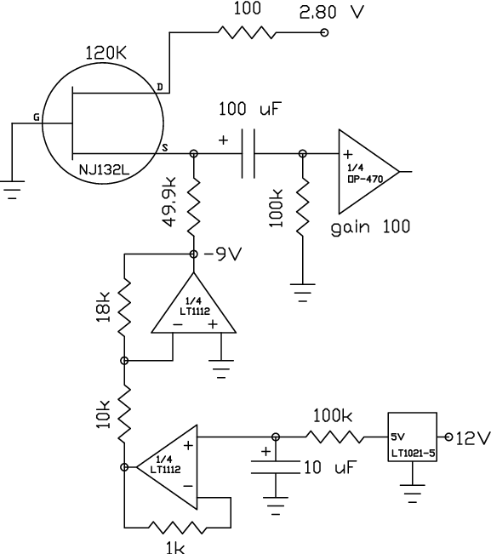
Figure 2 – Improved circuit for operating JFETs. The drain supply voltage has been reduced to 2.80 V with no penalty. The current has been increased by replacing the 499 kΩ resistor with a 49.9 kΩ resistor, which improves the JFET noise. The noise on the regulated –9V source supply (still shared) has been significantly reduced. The actual drain voltage is 2.19 V due to the voltage drop across the 100 Ω resistor. The circuit changes lower the source voltage by ~90 mV to typically 0.39 V.

To compare the improved circuit (Figure 2) to the original circuit (Figure 1), we re-tested quadrant B of substrate 9. Sixteen JFETs were operated at the original low current, and the remaining 16 were operated at the new high current. In the preliminary testing, we discovered and measured the noisiness of the -9 V 79L09A regulator, which contributes to the overall noise as shown in Table 4.

noise | contribution | (nV Hz^{-1/2})
3 Hz | 10 Hz | 30 Hz
7.1 | 3.7 | 2.5
Table 4 – Contribution of 79L09A noise to total noise for the circuit in Figure 1.

In principle, the noise in Table 4 could be subtracted in quadrature from the noise reported in Table 1 and in the spreadsheets supplied with the warm boards. In subsequent tests reported here, the –9 V supply made no significant contribution to the noise.

 | median | noise | (nV Hz^{-1/2}) | median src. | median
drain (V) | 3 Hz | 10 Hz | 30 Hz | V (mV) | DC gain
4.9 | 4.24 | 3.55 | 3.05 | 520 | 0.996
2.2 | 4.30 | 3.54 | 2.90 | 513 | 0.993
Table 5 – Effect of lowering drain voltage from 4.9 V to 2.2 V, for 19 μA JFET current. Measurements peformed on first half of 9B at 120 K.

drain (V), | median | noise | (nV Hz^{-1/2}) | median src. | median
current (μA) | 3 Hz | 10 Hz | 30 Hz | V (mV) | DC gain
4.9, 19 | ~5.3 | ~3.2 | ~2.8 | 523 | 0.996
4.9, 190 | 1.90 | 1.88 | 1.45
2.2, 190 | 2.06 | 1.44 | 1.23 | 435 | 0.991
Table 6 – Effect of increasing JFET current from 19 μA to 190 μA. Measurements performed on second half of 9B at 120 K.

Increasing the current by a factor of 10 reduces the noise by a factor of ~2, decreases the measured output impedance to ~500 Ω, and lowers the gain by a very small amount. Reducing the drain voltage has very little effect on the noise and gain.

 |  | 19 μA |  |  | 190 μA
 | median | noise | (nV Hz^{-1/2}) | median | noise | (nV Hz^{-1/2})
temp. (K) | 3 Hz | 10 Hz | 30 Hz | 3 Hz | 10 Hz | 30 Hz
75 | 45.20 | 20.22 | 10.91 | 37.93 | 13.92 | 6.99
80 | 49.14 | 23.06 | 11.71 | 61.47 | 24.20 | 9.95
90 | 12.59 | 11.75 | 9.14 | 26.69 | 27.02 | 16.37
100 | 6.71 | 5.39 | 4.88 | 6.32 | 6.82 | 5.88
110 | 4.82 | 3.72 | 3.50 | 2.84 | 2.54 | 2.34
120 | 4.30 | 3.54 | 2.90 | 2.06 | 1.44 | 1.23
131 | 6.37 | 3.79 | 3.09 | 2.95 | 1.87 | 1.24
140 | 9.78 | 4.74 | 3.19 | 5.89 | 2.24 | 1.38
Table 7 – JFET noise as a function of temperature for quadrant B of board 9 with 2.2 V drain.

An operating temperature of 120-130 K is preferred (Table 7, Figure 3). At colder temperatures (75 – 100 K), the average noise increases, and some individual devices become very noisy. There is a suggestion of a local minimum in the noise at 65-70 K. (See http://www.submm.caltech.edu/~cdd/fet/fet.html .)

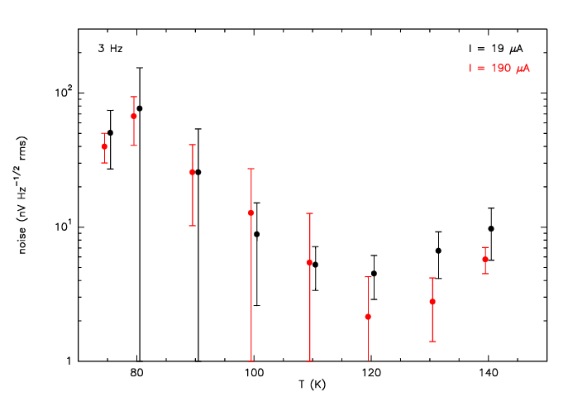
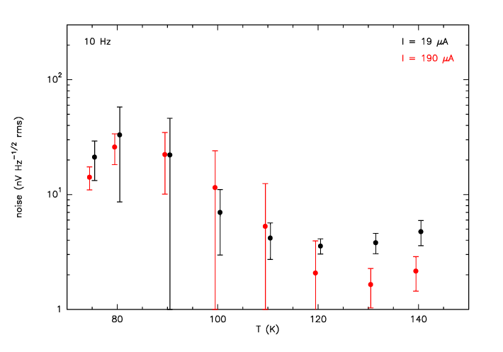
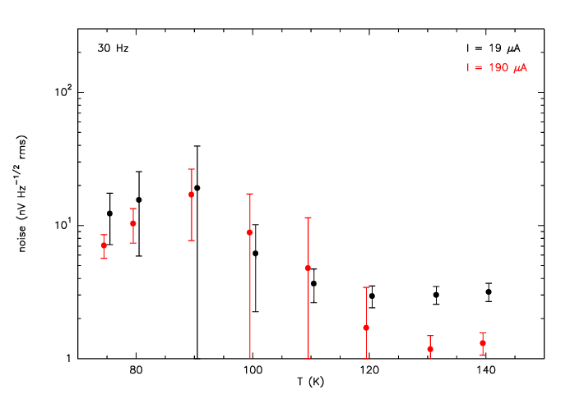
Figure 3 – Noise vs. temperature at 3 Hz, 10 Hz, and 30 Hz for low operating current (black points) and high operating current (red points). The mean and standard deviation (1σ) are shown.

