THE HEATSINK GUIDE: Case Cooling

Introduction
The best CPU heatsink is useless, if the air around it is too hot. The hot air obviously needs to be evacuated from the case. All computer cases come with a fan preinstalled in the power supply; if this fan isn't sufficient, you need to install an additional fan. The size of fan depends on the size of the fan bays in your case; if you have multiple fan bays, larger is better - bigger fans have a better ratio between air flow and noise. Where the fan is located, and in which direction it should blow, depends on your particular case - read below for some basic rules.

Should the PS fan in an ATX case exhaust air or blow air in?
According to the first version of the ATX specs, the power supply fan should blow air into the case, through the power supply towards the motherboard. The idea behind it was that this way, the CPU would be located directly in the airflow and would get along with a passive heatsink. With the CPUs available at the time the ATX 1.0 specification was made, this was a good idea; however, for modern CPUs a passive heatsink will not be sufficient, even if it is located in the power supply's air flow.
As the power supply gets hot, too, the fan would blow warm air towards the CPU, which of course isn't a good idea. Newer versions of the ATX specifications require the power supply to exhaust air, and almost all power supplies available on the market today are configured that way.

Should an additional fan blow in or out? Where should I install it?
This, as said above, depends on your case. Usually, depending on your case, there are two possiblilities for installing the fan: Either near the power supply on the back (either above, or below the power supply, right behind the CPU), or on the lower part of the front side.
If the second fan you install is located close to the first fan (e.g. you install the second fan above the power supply), then it must be installed in a way that it blows in the same direction as the first fan. If two fans installed next to each other will blow in opposite directions, they will create a "air short circuit", and adding a second fan might even decrease overall airflow.
If the second fan is installed at the opposite side of the case, then it should blow in the opposite direction of the PS fan. E.g. it the PS fan exhausts air, the second fan installed in the lower front part of the case should blow in. If both fans are sucking air out, then they would both try to create a vacuum inside the case, and there would be no real air flow.
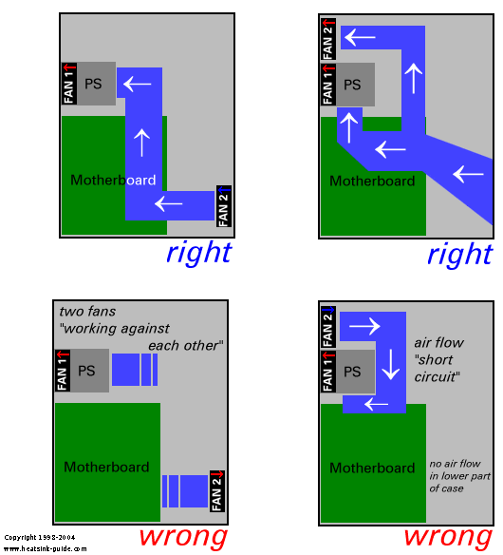
Another thing that should be mentionned is that if there are aeration holes in your case right next to the secondary fan, then it can sometimes be helpful to close these holes (for example using duct tape), because otherwise you'll also have a small "air flow short circuit".
These suggestions might seem a bit trivial to you. However, I've seen many incorrectly installed fans, so these tips might still be useful. The basic rule when installing fans is - as always - "use common sense".

A word about BTX case cooling
The BTX specifications, unlike the ATX specs, were designed from the beginning on to meet the cooling requirements of components with a high power dissipation.
As a rule, fans located at the front of a BTX case should blow fresh air into the case, and fans located at the rear should exhaust air. The orientation of the CPU fan should match this air flow direction (it should blow towards the back of the case).

Which fan should I chose? What about performance and noise?
Case fans come in many flavours. Usually, they are 80x80mm big; but there are also a few 92x92mm models available. If your case has a preparation for a secondary fan, make sure you buy a fan that has the right size for it. For more information regarding the correct choice of fans, consult the fan information page here on The Heatsink Guide.
If you feel shocked by the huge amount noise after installing your case fan, then this might often be improved by putting spacers between the fan and your case (less air turbulences, eliminates "vacuum cleaner effect"). Special rubber spacers are available, which additionally decouple the fan from the case, so that vibrations from the fan motor are not transferred to the case and thus amplified.
If your fan isn't temperature controlled, you can greatly reduce noise by adding a custom temperature control.

What is a "Fan Duct System"?
A fan duct, as the name suggests, is a tube that will lead cooling air on a precise path through your case. Advantages of fan ducts include:
- Heat from a heat source cooled with a fan can be directly removed from the case, instead of just moved around within the case.
- Components having high cooling requirements can be cooled using fresh air from outside the case.
- One fan blowing into the duct can be used to cool multiple heat sources within the duct, which is useful for noise reduction.
Larger computer manufacturers frequently use fan ducts as part of the cooling concept of their computers. Some PC cases found on the retail market come with retractable (telescopic) fan ducts, used in conjunction with a ventilation hole on the side of the case (also known as "blowhole").
Building your own fan duct can be an efficient no-cost solution for improving your PC's cooling. The image below shows a selfmade fan duct, built only from used packaging material (the clear plastic), and duct tape (now you know why it's called duct tape!).
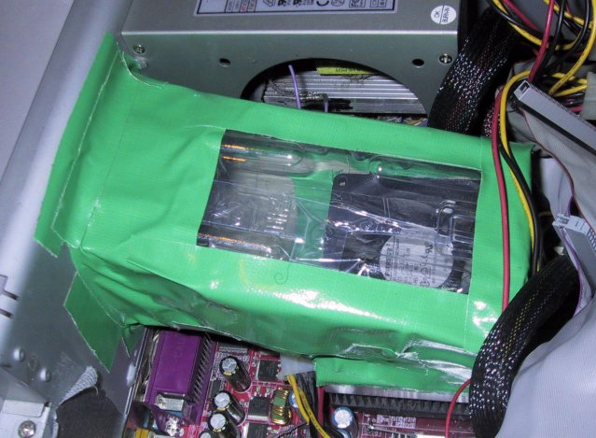
This simple and cheap construction helped lower case, CPU, and hard drive temperature by several degrees. This setup uses a CPU cooler which exhausts air from the CPU heatsink; the air duct leads the hot air to the ventilation hole in the case, so that CPU heat is directly removed from the case.
For overclocking a CPU, where low CPU temperature has the top priority, a different configuration is more advisable, where the fan sucks fresh air from the outside to the CPU. Note that the best orientation of your CPU fan's air flow (suck/blow) also depends on the design of your CPU heatsink.
Another method for building a simple, yet effective air duct is to attach a plastic tube to a blower (e.g. NBM/Radio Shack Ball Bearing Blower). The blower can be located outside of the case, and the tube is ajusted to blow fresh air there where cooling is needed the most. This allowes very targeted cooling of components like graphics cards.

